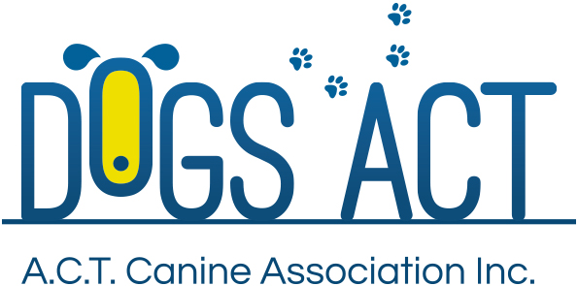
ACT Canine Association Inc. (ABN 11150955611) trading as Dogs A.C.T.
Exhibition Park, Federal Highway, Mitchell, ACT.
PO Box 815, Dickson ACT 2602. Phone 02 62414404.
Email: administrator@dogsact.org.au or visit: http://www.dogsact.org.au
Office hours 9.30am to 2.30pm Tuesday to Thursday

OBEDIENCE STEWARDS COURSE APPLICATION

NAME:

ADDRESS:
 |  |  |  | POST CODE:
CONTACT: | Home |  | Mobile

EMAIL:

DOGS ACT MEMBERSHIP:

OBEDIENCE CLUB MEMBERSHIP:

AGE (If under 15 years of age.)

Dogs ACT Obedience Stewards Panel – Applicant seeking inclusion on the Dogs ACT Obedience Stewards Panel must be:

- Financial Members of the ACT Canine Association Inc.
- Residents of the Australian Capital Territory
- Over 15 years of age

Successful completion - of the course will qualify candidates to be placed on the Dogs ACT Obedience Stewards Panel. Members between the ages of 15 and 18 will be place on the Junior Stewards Panel until they are 18.

Interstate Dogs ACT Members - are eligible to undertake the course provided their Canine Control has no objections. They should seek their Controlling Body's approval and provide written evidence of such approval with their application. Successful interstate Members will be place on the Supplementary Stewards Panel.

Non Dogs ACT Members - members of ACT Obedience Clubs who are not Dogs ACT Members will need to join Dogs ACT before applying to complete the Course.

Course Attendance - applicants are expected to attend all lecture and practical sessions in order to sit the exam.

Declaration by Applicant - I acknowledge that the (ACTCA) Dogs ACT Rules and Regulations governing the conduct of the Course and the decisions of the Council are binding and final.

Signed: |  | Date:

PLEASE FORWARD COMPLETED FORM TO:
THE ADMINISTRATOR,
DOGS ACT, PO BOX 815, DICKSON, ACT, 2602

