Choosing a Puppy
Once you have chosen the breed that best suits your age and stage of life and have found a responsible breeder that will give you ongoing support as you raise, train and live with your dog it is time to start thinking about the individual puppy that will be the next addition to your family.

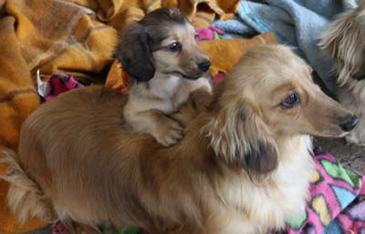

If you plan to show the dog let the breeder know so they can help you select a puppy that is more likely to grow into an adult that will be a good representation of the breed. There is no way to know for sure, but some puppies have obvious faults that would exclude them from the show ring so it is important to discuss your puppy’s future ‘career’ with the breeder.
Male or Female?
Some people have a preference, but in general, there is no significant difference in temperament between male and female dogs. If you are getting a dog for a pet, you will want to have your dog desexed, which will eliminate most minor differences anyway. If you plan to show or breed your dog, you must be vigilant about preventing unwanted breeding by keeping your intact male safely confined to your house or yard, and by keeping your intact female away from other dogs when she comes into season.

What about colour or markings?
Although you may have a certain colour of dog in mind, personality is the most important aspect of matching up a dog to a family. The breeder knows the puppies best – they will likely live with the mother every day and will have spent as much time as possible with the puppies during their eight weeks of developing and growing. Believe it or not, they have already started to develop a clear personality at this point.

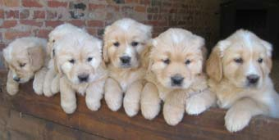

The breeder will have a relatively good idea of which ones will be more boisterous, stubborn, brave, shy, etc and will be able to match the puppy with the household. Wouldn't you rather have a dog whose personality matches well with your family than one who is the colour you always imagined but just doesn't seem to suit your lifestyle?

When visiting the litter look for a puppy that is:
- Happy and healthy and full of life
- Comes to you enthusiastically and wants to play
- Is not wary or scared of you or the breeder
- Does not look 'pot-bellied' - pot bellies can indicate worm infestation
- Inspect the puppy closely and make sure it is clean and there is no sign of fleas
- If the puppy has a long coat, make sure the coat is clean and not matted (tangled)
By taking home a happy, healthy puppy with a personality that suits your family you are giving yourself the best chance at having a wonderful companion and loyal friend for the next 10-15 years, maybe even more!

If you buy a purebred puppy from a Dogs ACT breeder it will have an ANKC Certificate of Registration. There are two registers on which a puppy can be listed, so please read Dogs ACT Registers (.pdf) so you can ensure the breeder provides you with a puppy that is eligible to participate in the activities you want.

