DANCES WITH DOGS - PURE FUN, PURE SPORT, BE CREATIVE

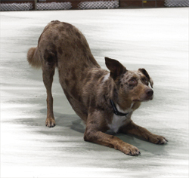
Dances with dogs is a new fun way to train and compete with your dog. Dances with dogs has two streams, freestyle and heelwork to music. Each stream has four separate levels and titles to each level. The levels are starters, novice, intermediate and advanced.
Freestyle is just that, technical moves to a piece of music. A handler is only limited by their imagination. It’s a way of taking all of the tricks and skills you’ve all being having fun with in the past and choreographing them to music to produce a snappy routine to catch the judges eye.

Heelwork to music involves traditional heelwork (dogs shoulder to handlers knee) choreographed to a piece of music. The twist is, in heelwork to music there are eight recognised heelwork positions. Doesn’t sound so simple now does it? As you progress through the levels, more of the eight positions should be included in a routine so that by the advanced level, the dog should be working in both left and right heel positions as well as front and back cross body heelwork. Add to this that in all eight positions the dog can be moving either forwards or backwards.
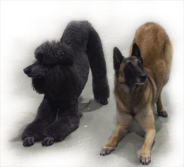

Further information
Further information about DOGS ACT activities including getting involved in Dances With Dogs, can also be found at www.dogsact.org.au OR call our office and speak to our staff during Business Hours (Tuesday, Wednesday or Thursday – 9.30 to 2.30) on 02 6241 4404.

