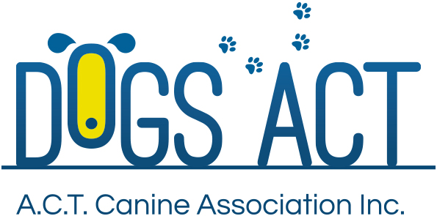

OBEDIENCE - PURE FUN, PURE SPORT

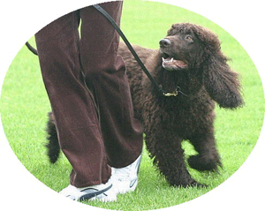

Why Obedience?
Dogs have many career opportunities open to them such as:
- showing, hunting, searching, rescuing, detecting, protecting, earth-dogging, pulling, guiding, assisting, tracking, herding, plus many other activities for which they were developed
- they can be seen trialling in obedience, agility, endurance and many other activities and competitions
- above all, most dogs are loving and loved companions
- many are multiskilled and can be seen doing one or several of the above in their busy lives
- but the most important thing to remember is that any of these activities demands an obedient dog because a dog which pleases itself and not its person is not much use at all

What do we do about it?
All of the above activities need a dog which has basic obedience to a certain extent and a set of commands which go with the actions, commands which it understands and which it will need to carry out its work.

It is well-known today that the sooner baby puppies get out and meet the world, the better they will be as adult dogs, getting on well with people and other dogs. This often starts with attending a puppy pre-school for puppies 8–12 weeks old, often run but a local veterinary clinic or the local obedience club.

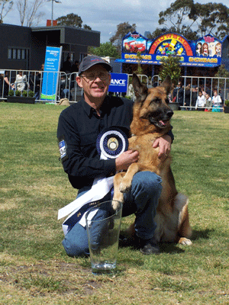
Once the puppy has had its first permanent vaccination at around 12 weeks, it can join a puppy class, which many of our affiliated obedience clubs run. These classes teach good manners and the basic obedience every dog needs to fit in with the world. They are the first step towards more formal classes which some owners wish to go on with and maybe eventually end up entering their dog in obedience trials.

A friendly warning should be issued here: Many unsuspecting owners have joined up with puppy in tow, only to find out obedience is fun, trialling is a great team sport, and many lovely friendships will be made along the way. Trialling may just possibly become an addiction involving whole families who then go on to explore other avenues with their dogs, like showing, tracking, earthdog, etc. Maybe puppies should come with a warning label!

Training dogs has changed a lot in recent years, with a huge emphasis on positive methods through which the dog learns by being placed in a situation where it will succeed and receives a reward of some sort – play, toys, food, pats - for its efforts. More traditional methods of training by unpleasant correction have been replaced because we have realised that the end product of positive teaching is a much happier, more willing dog who keeps asking for more, more, more.

Obedience Trialling
Trials are held in the ACT and throughout Australia during most of the year. To compete you need a trained dog that is registered with a controlling body – in the ACT it is DOGS ACT - and you must be a member too. Any dog can trial regardless of its parents, purebred or not. Dogs without registration papers trial as associates and everyone competes together.

All the exercises are based on useful things dogs can do for us and which make for a better companion.

There are five levels of obedience in Australia, they become progressively more challenging, the dog has to attain one title at a time working up a ladder. A title is completed when the dog has three passes at that level. Most levels require a pass of 175 points or more out of 200, and the dog must pass every exercise within the test. The exception is the entry class of Community Companion Dog which requires 75 points out of 100 on offer.

Community Companion Dog – CCD
In this class:
1. The dog and handler work together as a team to perform a heel on lead exercise, including sits, stands and downs as the judge calls them;
2. Next is stand for examination where the dog stands quietly on lead whilst the judge comes up and strokes the back and head;
3. Finally the dog is left sitting whilst the handler walks away 10 meters then turns and recalls the dog, which should come straight in and sit in front, the handler returns around it and releases, usually with much praise for a job well done; and
4. When all dogs in the class have had their turn, they all come together to do a one minute sit stay and a two minute down stay, all off lead in a row with the handlers standing six metres away.
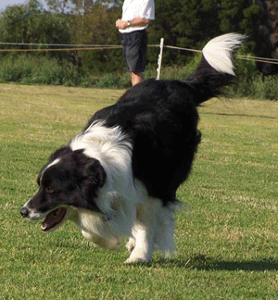

Companion Dog – CD
Things get a little harder here:
- The heeling exercise is off lead so it requires a lot more input and concentration from the dog to stay next to the handler;
- The stand for examination is also off lead with the handler standing two metres away;
- The recall is a bit longer at 12 metres and after the dog comes in and sits, it must go around the handler and sit at heel on the left side;
- The last exercise has a handler’s choice between retrieving a dumbbell over four metres or the dog doing a change of position where it is left in a stand and, with the handler three metres in front, goes into the down on command and stays there whilst the handler returns around it; and
- The stay exercises are harder too, the sit for a minute and the down for three minutes and the handlers are all 12 metres away.
Companion Dog Excellent - CDX
Most dogs love this, because it is fun, but the standard of the work is expected to be higher:
- The heeling is off lead and more demanding;
- The stand for examination has the handler five metres away and the judge touches all of the dog, except its mouth and tail;
- The recall has a drop somewhere in the middle of it, when the judge says, and must stay there until called in;
- The dog retrieves a dumbbell thrown at least six metres, sits in front, lets the handler take it, and returns to the handlers left side again;
- The other retrieve is over a solid jump set at the height of the dog measured at the shoulders;
- Next comes a handler’s choice between jumping over a broad jump and returning to the handler or a change of position where the dog is left in a stand and does a down and sit on the spot then recalls to the handler; and
- The stays have the handlers all leaving the ring and hiding nearby whilst the dogs do a three minute sit and a five minute down;
Utility Dog - UD
This gets really hard because the dog has to go away from the handler and do things which are really quite complicated, although it looks easy watching an experienced dog doing it.
- First is the seek back, where the dog and handler heel around the ring to make a track and somewhere along the track an article of the handler’s is placed, then the dog has to go and find this and bring it back and present it to the handler;
- Most dogs love directed jumping where they run out 25 metres and sit in a square frame, then return to the handler over a bar jump or a solid jump on either side of the ring, whichever the handler points to;
- The dog performs scent discrimination, either on a canvas mat or on the grass, there are 12 metal, wood and leather articles put out by the judge or steward, and the dog is sent to the articles to retrieve a similar article which the handler has touched, this is done three times, once for each sort of article;
- The heeling is harder because the handler is not allowed to speak, it is all done by signals, and at the end the dog is left in the stand, the handler signals it to down, sit, recall and finish
- A choice of three things, the dog can speak on command where it barks in the sit, stand and drop, or it can do food refusal where it refuses offered food in the sit, stand and drop or it may do directed retrieve where it retrieves the correct glove out of three placed six metres apart;
- The stand for examination is done as a group exercise; and
- The only stay exercise is a seven minute down with the handlers hiding somewhere.
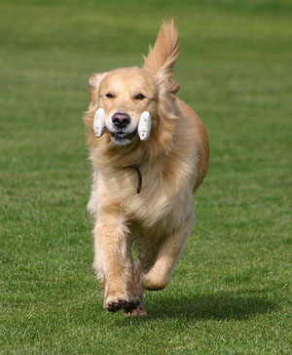

Utility Dog Excellent - UDX
This is a rather new title in Australia. It is very difficult but many handlers and dogs are enjoying the challenge of something new. There is no jumping, so it suits our older dogs.
- The seek back is as in utility but there is a decoy article scented by someone else which the dog must not retrieve;
- A heeling pattern, positions in motion, in which signals or voice may be used, and three times the dog is left in a sit, a stand or a drop whilst the handler walks forward five metres, returns three metres past the dog and returns, collecting the dog on the way;
- The scent discrimination is finding a cloth article scented by the judge from amongst unscented ones;
- A two part exercise, directed send away and recall in which the dog goes out 25 metres and sits in a square marked by four cones, the handler walks towards the dog and, when instructed, turns and calls the dog to heel, does a right or left turn then a halt, with the dog at heel by this time;
- The dog is left in a stand and changes position six times as the judge instructs, including sits, stands and downs, all on the spot, this is called distance control;
- The dog retrieves three articles which it cannot see, following the handler’s direction signal; and
- The last exercise is a temperament test which is a group stand for examination.
All these obedience titles are shown after the dog’s name and in fact becomes part of the registered name. There is one exception – obedience champion - this title is shown before the name as OC or O Ch, depending when the title was achieved. An obedience champion has gained his/her UD title, after which it has achieved a further five passes of 185/200 points or more in the utility class.

If you want to know more about the serious side of obedience trialling, you should contact any one of the three Obedience Clubs in the ACT:

ACT Companion Dog Club
www.actcdc.org.au ph: 02 6295 7764

Belconnen Dog Obedience Club www.bdoc.asn.au ph: 02 6241 799

Tuggeranong Dog Obedience Club
www.tdc.asn.au ph: 02 6293 4122

Further information
Further information about DOGS ACT activities including getting involved in Obedience, can also be found at www.dogsact.org.au OR call our office and speak to our staff during Business Hours (Tuesday, Wednesday or Thursday – 9.30 to 2.30) on 02 6241 4404.

