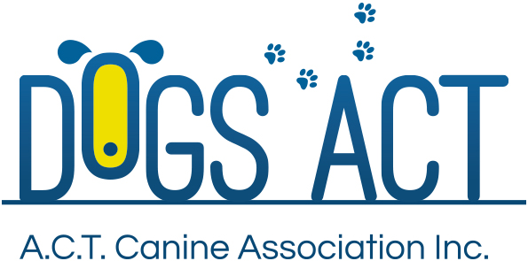
ACT Canine Association Inc. (ABN 11150955611) trading as Dogs A.C.T.

Exhibition Park, Federal Highway, Mitchell, ACT.
PO Box 815, Dickson ACT 2602. Phone 02 62414404.
Email: administrator@dogsact.org.au or visit: http://www.dogsact.org.au
Office hours 9.30am to 2.30pm Tuesday to Thursday.

AGGRESSIVE DOG REPORT
SHOW
DATE |  | TIME
NAME OF DOG
BREED
REGISTRATION NO |  | SHOW ENTRY NO
OWNER
ADDRESS
 |  | PHONE NO.
MEMBERSHIP NO.

NATURE OF COMPLAINT

REPORTED BY

NAME SIGNATURE

DOGS ACT INQUIRY COMMITTEE
RESULT OF INQUIRY

NAME | NAME | NAME
SIGNATURE | SIGNATURE | SIGNATURE

PLEASE ENSURE A PHOTOCOPY IS SUPPLIED TO THE OWNER OF THE DOG REPORTED AND TO THE AFFILIATE – IF THERE IS NO ACCESS TO THE PHOTCOPIER ON THE DAY, THEN TICK THE BOX TO THE RIGHT AND THE SECRETARY/REGISTRAR WILL MAIL THE COPIES ON THE FIRST DAY OF BUSINESS (ACTCA OFFICE HOURS) FOLLOWING THE SHOW CONCERNED

