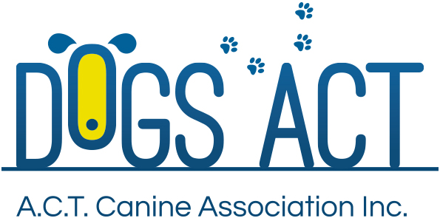
ACT Canine Association Inc. (ABN 11150955611) trading as Dogs A.C.T.

Exhibition Park, Federal Highway, Mitchell, ACT.
PO Box 815, Dickson ACT 2602. Phone 02 62414404.
Email: administrator@dogsact.org.au or visit: http://www.dogsact.org.au
Office hours 9.30am to 2.30pm Tuesday to Thursday

ASSOCIATE DOG REGISTER APPLICATION

Owner Of Dog:
Address:
 |  |  |  | Postcode
Phone No.: |  |  |  | Mobile
Common Name Of Dog:
Sex: |  |  |  | Age:
Breed Combination If Identifiable:
 | (Eg. Collie/Labrador X)
Colour:
Distinguishing Marks:
Veterinarian (Desexing)
 | (Copy of Certificate must be attached)
Microchip Number
Obedience Club:
Dogs ACT Membership No.
I CERTIFY THAT THE ABOVE DETAILS ARE CORRECT
Signature |  |  |  |  | Date
FEE $45.00 INCLUSIVE OF GST
OFFICE USE ONLY
Registration Number - |  | Microchip Number Confirmed YES / NO

