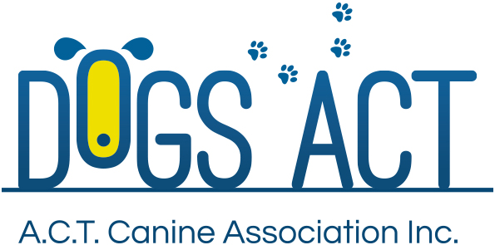
ACT Canine Association Inc. (ABN 11150955611) trading as Dogs A.C.T.
Exhibition Park, Federal Highway, Mitchell, ACT.
PO Box 815, Dickson ACT 2602. Phone 02 62414404.
Email: administrator@dogsact.org.au or visit: http://www.dogsact.org.au
Office hours 9.30am to 2.30pm Tuesday to Thursday

DUPLICATE CERTIFICATE OF REGISTRATION APPLICATION
Only one certificate of registration should exist for each ANKC registered dog ay any given time.
That dog must be resident in Australia and owned by a financial member of a State Canine Control.
REGISTERED OWNER :
ADDRESS:
 |  |  |  |  | POST CODE:
PHONE NUMBER: |  |  | MOBILE:
MEMBERSHIP NUMBER:
NAME OF DOG:
REGISTRATION No: |  |  |  |  |  | SEX:
REASON FOR DUPLICATE CERTIFICATE:
I CERTIFY THAT I AM THE OWNER OF THE ABOVE DOG AND I AM APPLYING FOR A DUPLICATE CERTIFICATE OF REGSITRATION:
Signature. |  |  | Date.
Signature. |  |  | Date.
FEE TO BE ENCLOSED IS $25.00 (GST Inclusive)
MAIL APPLICATIONS TO – PO BOX 815, DICKSON, ACT, 2602
OR RETURN THE APPLICATION TO THE OFFICE OF ACT CANINE ASSOCIATION,
SITUATED - DOGS GROUNDS, EXHIBITION PARK (EPIC) FLEMINGTON ROAD, MITCHELL.
YOUR APPLICATION FOR A DUPLICATE CERTIFICATE OF REGISTRATION WILL BY DETERMINED
BY THE COUNCIL OF THE ACT CANINE ASSOCIATION. THE COUNCIL MEETS ON THE SECOND
WEDNESDAY OF EACH MONTH.

