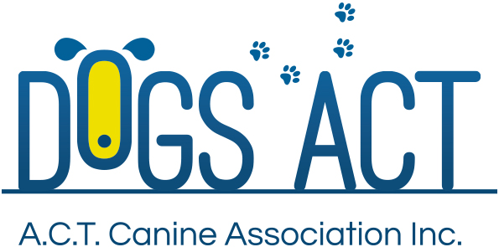
ACT Canine Association Inc. (ABN 11150955611) trading as Dogs A.C.T.
Exhibition Park, Federal Highway, Mitchell, ACT.
PO Box 815, Dickson ACT 2602. Phone 02 62414404.
Email: administrator@dogsact.org.au or visit: http://www.dogsact.org.au
Office hours 9.30am to 2.30pm Tuesday to Thursday

APPLICATION FOR EXPORT PEDIGREE |  | $100.00

BREED: |  |  |  |  |  | SEX.
NAME OF DOG:
REGISTRATION No:
MICROCHIP NUMBER:
APPLICANT/S:
MEMBERSHIP NUMBER:
ADDRESS:
POST CODE:
PHONE NUMBERS: |  | MOBILE:
SIGNATURE/S:
DATE:
ALL OWNERS MUST SIGN UNLESS PRIOR INSTRUCTIONS ARE LODGED WITH THE CONTROLLING BODY
IN SIGNING THIS FORM – THE OWNERS AGREE TO THE PUBLICATION OF THIS EXPORT AS PER ANKC REGULATIONS
NAME/S OF OVERSEAS PERSON/S WHOM DOG IS TO BE TRANSFERRED AND EXPORT MADE OUT TO.
ADDRESS:
COUNTRY:
PLEASE FORWARD THE COMPLETED APPLICATION TO:
ACT CANINE ASSOCIATIONS (DOGS ACT) – PO BOX 815, DICKSON, ACT, 2602
ADDRESS:
To prevent the loss of this document, it will be returned to the applicant to on forward to the new owner.
IMPORTANT: THE COMPLETED APPLICATION MUST BE ACCCOMPANIED BY THE
ORIGINAL REGISTRATION CERTIFICATION FILLED IN ON THE REVERSE WITH THE
DETAILS OF THE NEW OVERSEAS OWNER/S.
EXPORT CERTIFICATE $100.00 INCLUDING GST.
Dogs ACT - PO Box 815 Dickson, ACT, 2602

