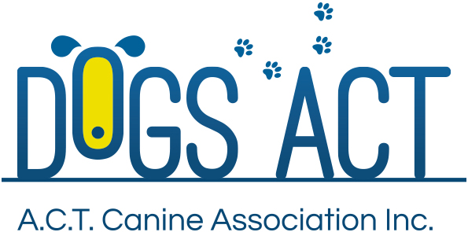
ACT Canine Association Inc. (ABN 11150955611) trading as Dogs A.C.T.
Exhibition Park, Federal Highway, Mitchell, ACT.
PO Box 815, Dickson ACT 2602. Phone 02 62414404.
Email: administrator@dogsact.org.au or visit: http://www.dogsact.org.au
Office hours 9.30am to 2.30pm Tuesday to Thursday

LIMITED REGISTER ACKNOWLEDGEMENT
All parties MUST sign this acknowledgement before the transfer will be processed.

REGISTERED NAME. |  | REGISTERED NUMBER.
BREED. |  | DATE OF BIRTH  / /
BREEDERS NAME. |  | DATE OF PURCHASE.  / /

I/We, the undersigned, acknowledge that it has been fully explained to me/us that the above dog is registered on the LIMITED REGISTER of the ACT Canine Association (Dogs ACT) in accordance to Dogs ACT and ANKC regulations.

It has been fully explained to me/us that the Breeder of the above dog has considered the following before registering the above dog on the Limited Register.

- The dog is ineligible for exhibition at a conformation show (includes all breeds show, championship show, open show, a parade, an approved competition or a breed specialty show) or,
- For any reason is not to be used for breeding purposes or,
- Is not entire or has been desexed or,
- At the time of registration, there is no benefit to the breed by registering the above dog on the main register or,
- Is not registered on the main register.
Dogs on the Limit Register will not be granted an Export Pedigree.

Only the Breeder of the above dog has the discretion to transfer the above dog to the Main Register.

PURCHASER – PRINT NAME |  | PURCHASER - SIGNATURE
PURCHASER - ADDRESS
BREEDER – PRINT NAME |  | BREEDER – REGISTRATION NUMBER
BREEDER - SIGNATURE |  | BREEDER - SIGNATURE
DATE SIGNED

THIS ACKNOWLEDGEMENT IS TO BE COMPLETED BY THE BREEDER AND NEW OWNER
AT THE TIME OF PURCHASE, AND MUST BE ATTACHED TO THE CERTIFICATE OF
REGISTRATION AT THE TIME OF TRANSFER.
Dogs A.C.T - Promoting Responsible Dog Ownership

