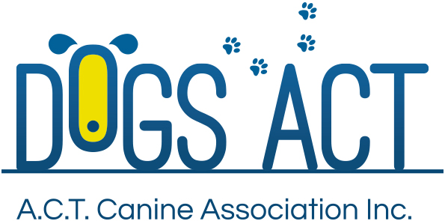
ACT Canine Association Inc. (ABN 11150955611) trading as Dogs A.C.T.
Exhibition Park, Federal Highway, Mitchell, ACT.
PO Box 815, Dickson ACT 2602. Phone 02 62414404.
Email: administrator@dogsact.org.au or visit: http://www.dogsact.org.au
Office hours 9.30am to 2.30pm Tuesday to Thursday

DOGS ACT REPRESENTATIVE - RETRIEVING & FIELD TRIAL REPORT
AFFILIATE:
LOCATION OF EVENT:
EVENT TYPE:
DATE HELD: |  | NUMBER OF ENTRIES:
TIME COMMENCED: |  | TEMPERATURE @ START:

VENUE PER ACT REGS? | Yes / No | (Reason if NO)
ACT REGS AVAILABLE: | Yes / No | (Reason if NO)
IF LATE START REASON:
IF LATE FINISH REASON:

LIST STEWARDS APPOINTED AND PRESENT FOR THIS EVENT:
JUDGES STEWARDS | GALLERY STEWARDS | GUN STEWARDS

GENERAL COMMENTS:

COMPLAINTS FROM EXHIBITORS & ACTIONS TAKEN: |  |  | Important - include witness details or list attached documents.
COMPLAINTS FEE LODGED: |  | RECEIPT DETAILS:

REPRESENTATIVES NAME: |  | SIGNATURE

INSTRUCTIONS FOR DOGS ACT REPRESENTATIVES

IMPORTANT: The Dogs ACT Representative -
- Is appointed on behalf of Dogs ACT to observe the conduct of the event & shall act only in that capacity & cannot personally carry out any other function on that day.
- Cannot be the President, Secretary, Event Manager or Treasurer of the Affiliate running the event.
- Must obtain a copy of the ACTCA Rules & Regulations from the Dogs ACT Administrator prior to the event concerned if he or she is not already in possession of the Rules, & they must become familiar with them.
- Must obtain a copy of the ACT Representative’s Report form prior to or on the day of the event & complete it immediately at the conclusion of that event.
- If an exhibitor or other person (excluding members of the general public visiting the event) wishes to lodge a complaint, this complaint must be submitted to Dogs ACT Representative in writing on the day together with $100.00 in accordance with Regulation Part 18 Section 3 unless it is an Aggressive Dog Complaint.
- On completion of the event, must obtain the Judges Cards or Trial sheets & a marked copy of the Trial Catalogue. These items together with the ACT Representatives Report and any written complaints, must be lodged with the Dogs ACT Administrator at the Dogs ACT Office, EPIC, Federal Highway, Canberra or PO Box 815, Dickson ACT 2602 within two (2) working days of the event.

