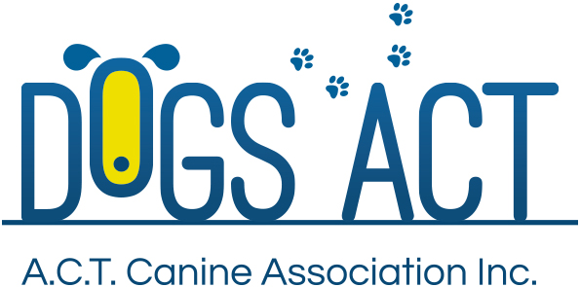  ACT Canine Association Inc. (ABN 11150955611) trading as Dogs A.C.T.  Exhibition Park, Federal Highway, Mitchell, ACT.  PO Box 815, Dickson ACT 2602. Phone 02 62414404.  Email: administrator@dogsact.org.au or visit: http://www.dogsact.org.au  Office hours 9.30am to 2.30pm Tuesday to Thursday | FEE  ENCLOSED $35.00  INCLUDES GST

APPLICATION - SPORTING REGISTER

OWNER OF DOG:
ADDRESS:
 |  |  | POSTCODE:
PHONE NO/S:
DOG ACT MEMBERSHIP NUMBER
NAME OF DOG:
SEX: |  | AGE:
BREED:
REGISTRATION NUMBER:
COLOUR:
DISTINGUISHING MARKS:
REGISTERED WITH (see next information):
PLEASE NOTE:
- This application must be accompanied by the following documentation:
  - Certified copy of the dog’s registration with one of the ANKC recognised bodies as listed on the bottom of this form showing you as the registered owner/s with an ACT residential address. (See over page).
  - Microchip and or tattoo details where applicable.
- If your dog is already registered as an “Associate” and you wish to register on the “Sporting Register” then you must surrender the original certificate of registration.
This ensures that all titles gained as an “Associate” will be transferred to the “Sporting Register”.
- The applicant must be a financial member of Dogs ACT.

I CERTIFY THAT THE ABOVE DETAILS ARE CORRECT
Signature |  |  |  |  | Date
Signature |  |  |  |  | Date
OFFICE USE ONLY
Registration Number
Microchip Number
Date received. | Date processed. |  |  | Date Filed.

ANKC LTD LISTING OF RECOGNISED WORKING DOG ASSOCIATIONS
OR KINDRED BODIES AS REFERENCED IN CHAPTER 8 OF THE
RULES AND REGULATIONS FOR HERDING TRIALS
[NOTE: Additional listings may be added upon receipt of submissions by the ANKC Ltd
Administrator for consideration by the National Herding Committee.]

Name
The Working Kelpie Council of Australia Inc.
Breed Society for The Australian Working Kelpie
Australian Working Border Collie
Australian Sheepdog Workers' Association
NSW Sheepdog Workers Inc
New South Wales Yard Dog Association Inc.
Queensland Working Sheep Dog Association
Queensland Cattle Dog Trial Association
SEQ Paddock Workers Association
South Australian Working Sheepdog Association Incorporated
Tasmanian Working Sheep Dog Association Incorporated
The West Australian Working Sheep Dog Association and Associated Clubs as follows:
Esperance & Districts Working Sheep Dog Club
Stirling Working Sheep Dog Club
Mayanup Working Sheep Dog Club.
Central Districts Working Sheep Dog Club.
Northern Districts Working Sheep Dog Club.
Koolie Club of Australia
Working Koolie Association Australia Inc.
New Zealand Sheep Dog Trial Association (Inc)

