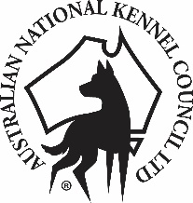

MEETING OF NATIONAL BREED COUNCILS

NOTICE OF MEETING

Notice is hereby given that the next meeting of National Breed Councils will be held on Saturday, 1 July 2017 commencing at 10.00 a.m. at:

Dogs Victoria Bulla Exhibition Centre
Calabria Club
5 Uniting Lane
BULLA Victoria 3428

National Breed Councils are invited to submit agenda items for this meeting to the ANKC Administrator, by no later than COB 28 April 2017 to allow sufficient time for the agenda to be promulgated prior to the meeting.

National Breed Councils are invited to send two representatives to attend the meeting. The names of your representatives are to be submitted to the ANKC Administrator, by no later than COB 16 June 2017. Only those delegates confirmed by their respective National Breed Council will be permitted entry to the meeting.

T Barry
ANKC Ltd Administrator

