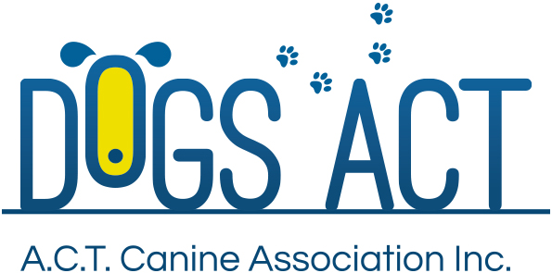 |  | APPLICATION FOR ACCEPTANCE TO THE OBEDIENCE  JUDGES TRAINING SCHEME  OPEN

Applicant Information
Name: |  | First Name:
Current Address:
City: | State: |  | Postcode:
Phone: |  | Mobile:
Email:
Dogs ACT Membership No: |  | Date Joined:

applicant declaration
I declare that:
- I have been a member of an Australian Canine Controlling Body for five (5) years.
(Give details if other than the Dogs ACT):
- I am over twenty one (21) years of age
- I am resident in the ACT
- I was admitted to the Dogs ACT Obedience Steward's Panel in ^{year}
(Provide supporting documentation if other than Dogs ACT Panel)
- I have been actively instructing Obedience Trialing level classes at a Dogs ACT affiliated Club for at least two (2) years preceding this application
- I hold a Novice Judges Licence
- I have personally trained and trialed a dog to its’ Open or higher title

details of THE dog you personally trained and trialed to it’s OPEN title
Name:
Registration No:

details of THE OPEN qualifying scores which you personally achieved
Trial 1 – Club:
Date: |  | Judge:
Trial 2 – Club:
Date: |  | Judge:
Trial 3 – Club:
Date: |  | Judge:

APPLICANT’S SIGNATURE
Signed: |  | Date:

STATEMENT BY THE PRESIDENT/SECRETARY OF THE APPLICANT'S OBEDIENCE CLUB

I confirm that the applicant:
Applicant’s Name:
is an instructor at this Club and has been satisfactorily instructing at Open and other levels over the past two (2) years.
Name of Club Official (Please Print)
Signature of Club Official:
Office Held
Date:
Club:

APPLICATION FEE: $55.00
PAYABLE AT THE TIME OF SUBMISSION OF APPLICATION

