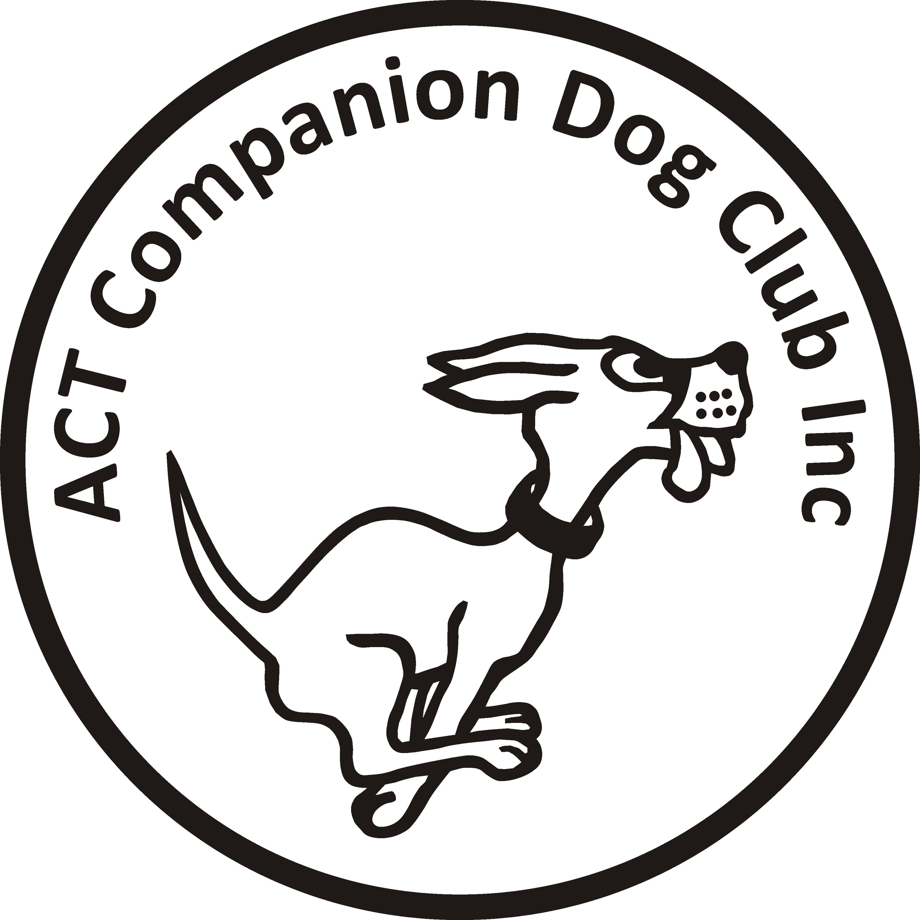
Entries close: Saturday 9 June 2017

ACT COMPANION DOG CLUB
DOUBLE OBEDIENCE TRIAL
Saturday, 17 June 2017

Venue: ACT CDC grounds, 240 Narrabundah Lane, Symonston ACT 2609
AM TRIAL PM TRIAL
Judges UDX Mr Graeme Field (NSW) UDX, CDX, CD Mr Charlie Giles (ACT)
UD, CCD Mr Charlie Giles (ACT) UD, CCD Mr Ron Probert (NSW)
CDX, CD Mr Ron Probert (NSW)

Starts 9.00 am Not before 12.00pm
Check-in 8.15 - 8.45 am 11.15 – 11.45 am
Entry fee $11.00 $11.00

Entries to Show Manager
Or by post to Obedience Trial Manager, ACT Companion Dog Club, PO Box 4048, Kingston ACT 2604. Pay online: ACT CDC - BSB: 032-729, Account: 235628, Ref: OB0617 + surname + phone number
Catalogues posted on ACT region obedience & rallyo trialling group Facebook page
or, if requested, to email address on your entry form.

All enquiries Judith Barlow - 0403 199 847 no calls after 9pm, judespitz@netspeed.com.au
Awards Sash for 1st, 2nd and 3rd place for qualifying scores.
Sash for all qualifying scores and titles gained on the day.
Notes: The Club reserves the right to make any changes to ensure the smooth running of the trial, including substituting or appointing additional judges, and accepting or rejecting entries.
No off-leash exercising of dogs on grounds except in designated fenced areas.
The Club shop will be open for meals, refreshments and treats for your dog.

