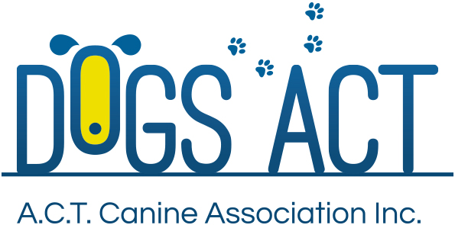

RALLY OBEDIENCE

Rally Obedience (commonly called Rally O or just Rally) was created to promote a positive relationship between the dog and its owner. The emphasis is on fun and excitement for the dog and handler.
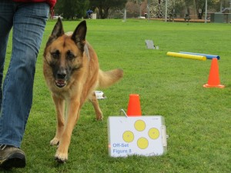
Rally O is often described as a combination of Agility and Obedience. A Rally O course is set out with numbered stations including a start and finish. Like Agility, handlers have the opportunity to walk the course to become familiar with it before competing. Participants then navigate the course by following the numbers and carrying out the exercise shown on the sign positioned at each of the numbered stations. Dogs work in the “Heel” position between exercises. At Novice level, dogs negotiate a course having between 10 and 15 signs (not including the start and finish) and work on lead during the test. There is a total of 50 signs gradually increasing in complexity. The higher levels of Rally O use up to 20 signs including many of the more complex ones and complete the courses off-lead.
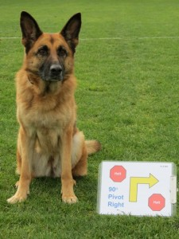
Rally O was designed with the average dog owner in mind, as a way to introduce them into the world of dog sports and for people to just have fun with their dog. It is also suitable for accomplished Obedience or Agility triallers. It provides them with another way to interact with their dog, particularly as their dog becomes older and less able to manage some of the more strenuous aspects of those sports.

In Rally O competitors complete the course on their own and are allowed to use multiple hand and verbal cues and can talk to, praise and encourage their dog throughout the performance – it has a far more relaxed atmosphere than other dog sports. Each run is a different series of exercises – you never know what the course will be until you do the preliminary walk through.

If you want to know more about RallyO, you should contact any one of the three Obedience Clubs in the ACT:

ACT Companion Dog Club
www.actcdc.org.au ph: 02 6295 7764

Belconnen Dog Obedience Club www.bdoc.asn.au ph: 02 6241 799

Tuggeranong Dog Obedience Club
www.tdc.asn.au ph: 02 6293 4122

Further information
Further information about DOGS ACT activities including getting involved in Rally Obedience, can also be found at www.dogsact.org.au OR call our office and speak to our staff during Business Hours (Tuesday, Wednesday or Thursday – 9.30 to 2.30) on 02 6241 4404.

