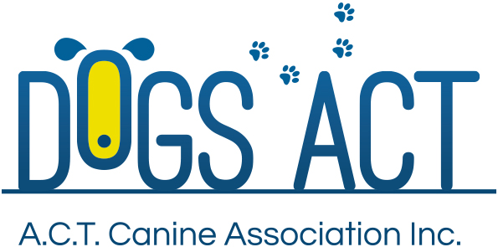

Dog Spectacular in the ACT Flyball Racing
2 Sanctioned Race Meetings

Race Meet 1 Saturday 8 July 2017
Race Meet 2 Sunday 9 July 2017

Entries close: 1 June 2017
Venue: Fitzroy Pavilion, EPIC. Corner of Flemington Road and Northbourne Avenue, Mitchell.
Judges: Josh Ellen (VIC),
Roycelyn Clyde (ACT),
Robyn Ferguson (NSW)
Phil Lea (NSW)

Racing Commences: 8:00 am
Entry Fees: $150.00 per team per race meet
Entries: PO Box 6020 Lanyon ACT
Entry fees: Dogs ACT BSB: 112 908 Account: 050051244
- Please include Club, Team name and Race Meet number(s) with payment
Entries close Friday 9 June 2017

Contact: flyball@bdoc.asn.au

Regular and Open Divisions. No Veterans’ class

Camping is available in regular camping areas. Please contact EPIC on (02) 6205 4976 or Email: campingepic@act.gov.au Hire caravans can be booked though B&V Caravans (02) 6299 1101 or Caravan Connections 0417 266 921

Proudly sponsored by EPIC Love’ em and Advance

