Weight Pulling with your Dog

Weight pulling is an activity that many breeds of dog enjoy. In Australia, the activity is generally conducted on natural, flat surfaces such as clean gravel or grass, however, weight pull can be held on any surface which allows for non-restricted movement to the pulled loaded trolley.

Several clubs throughout Australia conduct weight pull events - contact your State's canine association, or breed clubs such as Alaskan Malamute, Siberian Husky or American Staffordshire Terrier Clubs to find out if they hold weight pull events.

General fitness of your dog must be maintained when weight pulling. Pulling heavy loads can place unnecessary strain and lead to injury if your dog is not in sound physical condition.

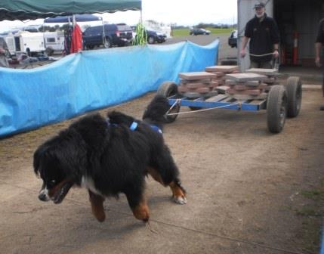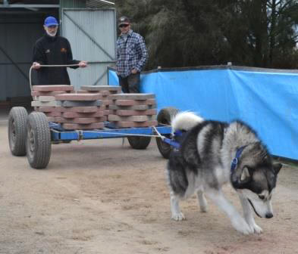

In competition

All that you need to compete in Weight-Pull events is a healthy dog over the minimum age and weight requirements, and a correctly fitted weight pull harness. The dog must first qualify for the event by pulling a 4 wheeled trolley of a qualifying weight (usually around 160 kg) a distance of 5 metres within a limited time of 60 seconds.

After each dog has attempted the pull, the trolley is loaded with more weight. Dogs that successfully pulled the previous weight then attempt to pull the next highest weight. A dog is out of the competition if it fails to pull the loaded trolley within the allocated time, and the dog's result is recorded at the highest weight successfully pulled.

To be successful in weight-pulling, your dog needs to be trained to pull on voice command, as the handler is usually not permitted to use any form of bait or enticement to get the dog to pull in competition. The dogs that perform the best are not necessarily the largest dogs, but more importantly those with good pulling technique and the right attitude. These dogs really want to pull and have learnt to lean into their harnesses to get the weight-pull trolley moving.

Most events offer a range of weight-classes so that smaller dogs are not competing against significantly larger dogs. The results of the competition are based on the overall weight that the dog pulled within the class, as well as weight to weight ratio, that is, how much the dog pulled relative to its body weight.

Note that bitches in season are generally not permitted at a weight pull event as they provide too much of a distraction to other dogs.

Who Can Participate?

Anyone with a healthy dog over the minimum age requirement (usually 18 months) can participate – you generally don’t have to be a club member and it doesn’t matter what breed of dog you have or if the dog has ANKC registration papers or not. It is important that the handler be well prepared to embarrass themselves. As often is the case, the handler must display humorous and sometimes embarrassing techniques in order to have your dog come on command. Very entertaining for spectators, even if humiliating for the handler!
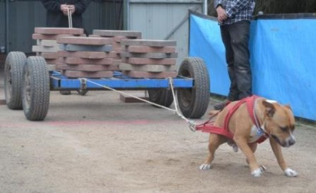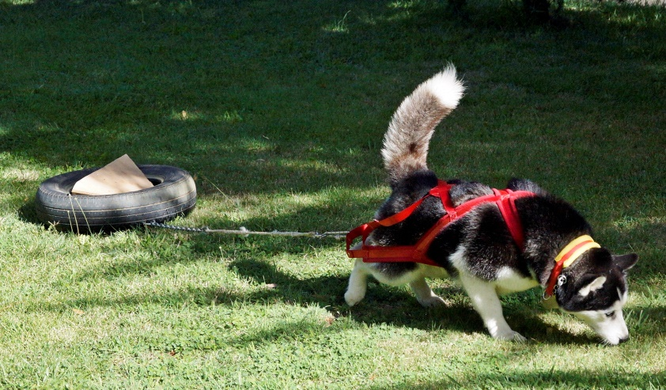

Equipment

To participate in weight pull activities with your dog you will wear a weight pull harness, and a fixed or flat collar. The harness is the most critical piece of equipment for the dog and is specifically for weight pull purposes. Harnesses are made to measure for each individual dog to ensure good fit, and are made from strong, lightweight webbing with padding around the neck and chest to maximise comfort for the dog and minimise the risk of injury or discomfort. For training, a cheap and easy option is to teach the dog to pull tyres attached to the harness via a long rope. You can select from a range of tyre weights and load them with bricks to suit the ability and progress of your dog.

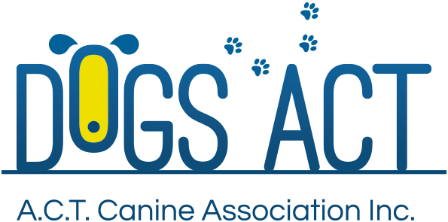

Dogs ACT is proud to host two Weight Pull Competitions as part of the Advance International Dog Show and Trial Extravaganza. Saturday 8 July at 12 noon and Sunday 9 July at 9 am

More information is on this Site: https://www.windchill.com.au/WeightPulling.html
Contact: Richard Herba: 0488 099 509 siberians@ozemail.com.au

