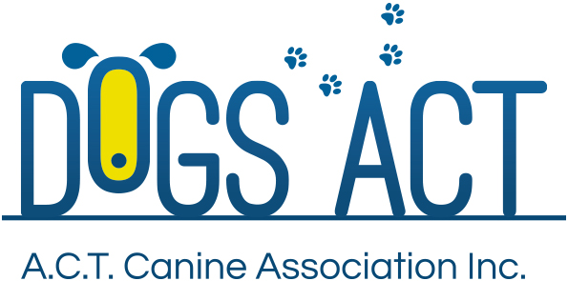

October Long Weekend Selected Group Specialty Shows

Saturday 30th September and Sunday 1st October 2017

**Exhibition Park in Canberra, Federal Highway, Canberra**

Classes: 1, 2, 3, 4, 5, 10, 11 & 18 (dogs & bitches)

|  |  |  |
| --- | --- | --- |
| GROUP | SATURDAY | SUNDAY |
|  |  |  |
| Terriers | Ms Liz Hindley (ACT)  Judging commences 9.00am | Ms Ann Meyn (NSW)  Judging commences 9.00am |
| Hounds | Ms Ann Meyn (NSW)  Judging commences not before 12 noon |  |
| Working Dogs |  | Ms Belinda Hales (NSW)  Judging commences 10.30 am |
| Utility | Ms Liz Hindley (ACT)  Judging commences not before 11.00 am | Mr Derek Hyde (ACT)  Judging commences 10.30am |
| Non Sporting | Ms Ann Meyn (NSW)  Judging commences 10.00am | Mrs Toni Denis (NSW)  Judging commences 9.00am |

**Judging commences:**  As indicated above

**Trophies:** Trophy and sash

**Entry Fees:** $12.00 per class, numbers to be collected at the show

**Remittances**: Dogs ACT

**Catalogue**: $5.00 pre ordered or online only, there will be a combined catalogue for each day, **no catalogues available for sale on the day**

**Entries close:** 15 September 2017

**Email enquiries:** [admin@dogsact.org.au](mailto:admin@dogsact.org.au)

**NUMBER CARDS TO BE COLLECTED ON THE DAY OF THE SHOW**

|  |  |
| --- | --- |
| **Entries to:** | Show Secretary, PO BOX 815  DICKSON ACT 2602  Ph: 62414404 – during Business Hours OR  email: admin @dogsact.org.au |

***Dogs ACT reserves the right to change or reallocate judges as necessary.***

***Show Committee members do not handle at these shows.***

**On grounds camping must be pre-booked, phone 02 6241 4404**  
