ENTRIES CLOSE 15 SEPTEMBER 2017
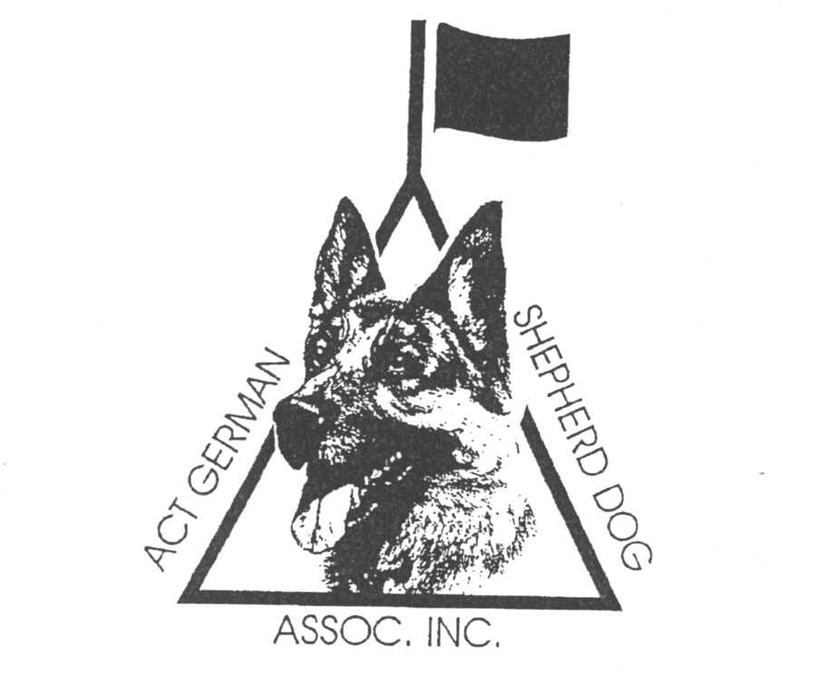
To be held at the Club Grounds, EPIC, Flemington Road, Mitchell
The ACT German Shepherd Dog Association Inc
Two Championship Shows
Saturday 30 September 2017 and 1 October 2017

Saturday, 1 October 2016  Judges: Dr Hugo Vergara Araque (Equador) Bitches  Snr Jens Becker-Olsen (Spain) Dogs & LSC Bitches & Dogs | Sunday, 1 October 2017  Judges: Snr Jens Becker-Olsen (Spain) Bitches  Dr Hugo Vergara Araque (Equador) Dogs & LSC Bitches & Dogs
Judging commences 8.30am both days.
Entry fees (for each show) Initial $38 Subsequent $33
Baby Puppies – Initial $28 Subsequent $23
Catalogue included with initial entry fee (additional catalogues $5.00)
Please note they are two separate shows on the same weekend and
a separate entry form is required for each day.
The Show Secretary, ACTGSDA, PO Box 893, Dickson ACT 2602
Phone: (02) 6223 2217 (Margaret Barnes) Email: mlb@supervine.com.au
The ACT reserves the right to appoint a substitute judge if necessary.

