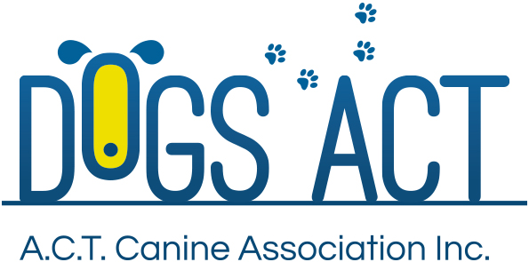
Summer Festival Shows
Saturday 27th and Sunday 28th January 2018
Four All Breeds Championship Shows over two days
Exhibition Park in Canberra, Federal Highway, Canberra
Classes: 1, 2, 3, 4, 5, 10, 11 & 18 (dogs & bitches)

 | SATURDAY 8.00 AM | SATURDAY PM  Not before 12.00 noon | SUNDAY 8.00 AM | SUNDAY PM  Not before 12.00 noon
Toys | Ms. B. Lacey (QLD) | Mrs. K. Hutchings (S.A) | Mr G. Kill (QLD) | Ms. K. Rolfe (N.S.W)
Terriers | Ms. K. McGhie (QLD) | Ms. M. Webber (QLD) | Mr. L Wright (QLD) | Ms. P. Brown (QLD)
Gundogs | Ms. P. Brown (QLD) | Ms. A. Carius (QLD) | Ms. M. Webber (QLD) | Mrs. K Hutchings (S.A)
Hounds | Ms. A. Carius (QLD) | Ms. B. Lacey (QLD) | Mrs. K. Hutchings (S.A) | Mr. G. Kill (QLD)
Working Dogs | Mrs. K. Hutchings (S.A) | Ms. K. McGhie (QLD) | Ms. P. Brown (QLD) | Mr. L Wright (QLD)
Utility | Mr. G. Kill (QLD) | Ms. P. Brown (QLD) | Ms. K. McGhie (QLD) | Ms. M. Webber (QLD)
Non Sporting | Ms. M. Webber (QLD) | Mr. G. Kill (QLD) | Ms. A. Carius (QLD) | Ms. K. McGhie (QLD)
GENERAL SPECIALS | Ms. P. Brown (QLD) | Ms. K. McGhie (QLD) | Mr. G. Kill (QLD) | Ms. M. Webber (QLD)

Judging commences: 8.00 am – AM Show and not before 12.00 Noon for the PM Show
Trophies Trophy and sash
Entry Fees: $13.00 per class, numbers to be collected at the show.
Remittances: Dogs ACT
Catalogue: $5.00 pre ordered or online only, there will be a combined catalogue for each day, no catalogues available for sale on the day
Entries close: 10th January 2018 (postal)
9.00am 23rd January 2018 (online)
NO REFUNDS AFTER 10th JANUARY 2018
Email enquiries: admin@dogsact.org.au
NUMBER CARDS TO BE COLLECTED ON THE DAY OF THE SHOW
Dogs ACT hot weather policy applies – PH (02) 6241 4404
SUNDAY SHOW TO HELD UNDER THE MARKET SHEDS
Entries to: | Show Secretary, PO BOX 815  DICKSON ACT 2602  Ph: (02)6241 4404 (9.30am to 2.30pm)  email: admin @dogsact.org.au
Dogs ACT reserves the right to change or reallocate judges as necessary.
Show Committee members do not handle at these shows.
On grounds camping must be pre-booked, phone 02 6241 4404

