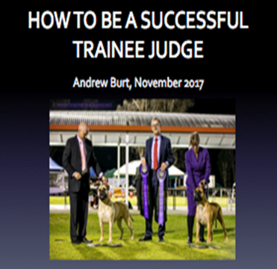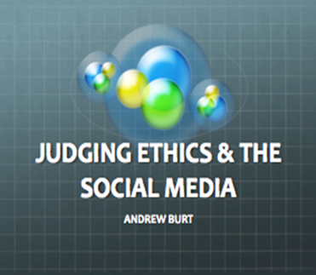  17 March 2018  Dogs ACT would like to invite members to attend:  MR ANDREW BURT’S LECTURE SERIES  Andrew Burt is an Educator, All Breeds Judge, and past DV Conformation Judges Committee member, and has coordinated several Groups for Judges Training  Andrew will present a series of three presentations:  • How to be a successful Trainee Judge;  • Critiquing; and  • Judging ethics & the social media  Please contact Dogs ACT on 6241 4404 during office hours Monday to Thursday 9:30am to 2:30pm to make your booking | VENUE:  Dogs ACT meeting rooms  ────  TIME:  10am Saturday 17 March 2018  ────  COST:  $10 prepayment required for catering purposes  ACT Canine Association Inc. (ABN 11150955611) trading as Dogs A.C.T.  Phone 02 6241 4404  Email: admin@dogsact.org.au

