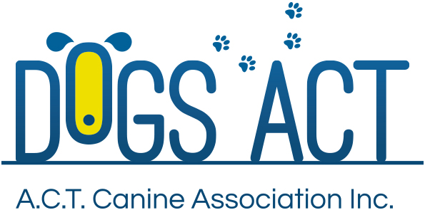
ACT Canine Association Inc. (ABN 11150955611) trading as Dogs A.C.T.

Exhibition Park, Federal Highway, Mitchell, ACT
PO Box 815 Dickson ACT 2602 Phone 02 6241 4404
Email: admin@dogsact.org.au or visit: http://www.dogsact.org.au

2018 CONFORMATION JUDGES’ TRAINING SCHEME
APPLICATION FOR TRAINEE JUDGE

I hereby apply for a licence as a trainee judge for the following group(s)
Group ……………………………………………..

Group ……………………………………………..
Training fee per group $65.00

Mr/Mrs/Ms Membership No
(First Name) (Last Name)

Address Postcode
Phone: . Email:
DECLARATION:
I hereby apply to enrol in the Dogs ACT 2018 Conformation Judges’ Training Scheme on the terms and conditions set out in the 2018 Trainee/Aspirant lecture program and the following Regulations:- (i) ANKC Regulations Part 3- Judges Training & Examination Program (available on ANKC website www.ankc.org.au) and (ii) Dogs ACT Regulations (available on Dogs ACT website www.dogsact.org.au).

I declare that I am physically fit and capable of judging in accordance with the Regulations and in the normal acceptable manner, and if required I am prepared to undergo a medical fitness test and/or vision test at the discretion of Dogs ACT. I further accept Dogs ACT may at its absolute discretion refuse to grant any renewal of licence and may cancel or suspend for any period or vary in any way any licence already granted or to be granted. Or may grant, in part, only an application for renewal of licence.
Signature of Applicant Date
This Application must be received by Dogs ACT, together with the application fee of $65.00 per group, NO LATER than COB on Thursday 29 March 2018 either by post to Dogs ACT, PO Box 815, Dickson ACT 2602 or delivered by hand during Dogs ACT office hours.
_______________________________________________________________________________________
Credit Card Details
Mastercard Visa Expiry Date /
Card Number
Please debit my credit card the amount of $................... Signature:
FEES ALSO PAYABLE BY CHEQUE OR MONEY ORDER – ALL REMITTANCE PAYABLE TO DOGS ACT

