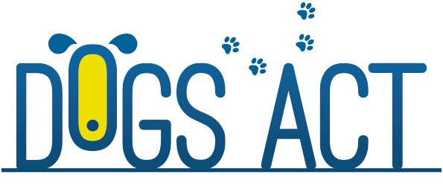

Agility, Jumping and Games Trial
Agility Titles
6th & 7th October 2018

Entries close : 21st September 2016
Venue: ACT CDC Club Grounds, Narrabundah Lane, Symonston
Judges:
Saturday 6th October
Mr Peter Hofto (TAS) AD, ADX, ADM, ADO, SD, SDX, SDM
Mrs Libby Ellery (NZ) JDO, JDM, JDX, JD, GDX, GDM, GD
Sunday 7th October
Mr Peter Hofto (TAS) ACT Jumping Dog of the Year Final
JDO, JDM, JDX, JD TITLES
SPDM
Mrs Libby Ellery (NZ) ACT Agility Dog of the Year Final
AD, ADX, ADM, ADO TITLES
SPDX, SPD

Commences: 9.00am Saturday 6th 8:30am Sunday 7th
Entry Fees: $10.00 per entry
Entry to Agility & Jumping Dog Of The Year Finals are by invitation and at no charge.
Rules can be viewed on Dogs ACT website & ACT Agility Facebook page.
Catalogues: $10.00 (covers both days) or free online via ACT Agility Facebook page or ACT_Agility Yahoo group no sooner than 3 days before the trial
Entries via E Performance (preferred) or with: Agility Trial Manager, 18 Euroka Street,
Narrabundah, ACT 2604
Contact: Ph or text: 0405 345 237 no calls after 9.00pm. Email gundogz@tpg.com.au
Prizes Prize & Sash awarded for 1st, 2nd & 3rd qualifying places
Prize & Sash for winners of Agility Dog Of The Year and Jumping Dog Of The Year
Not For Competition entries will be accepted in accordance with Dogs ACT Regulations.

