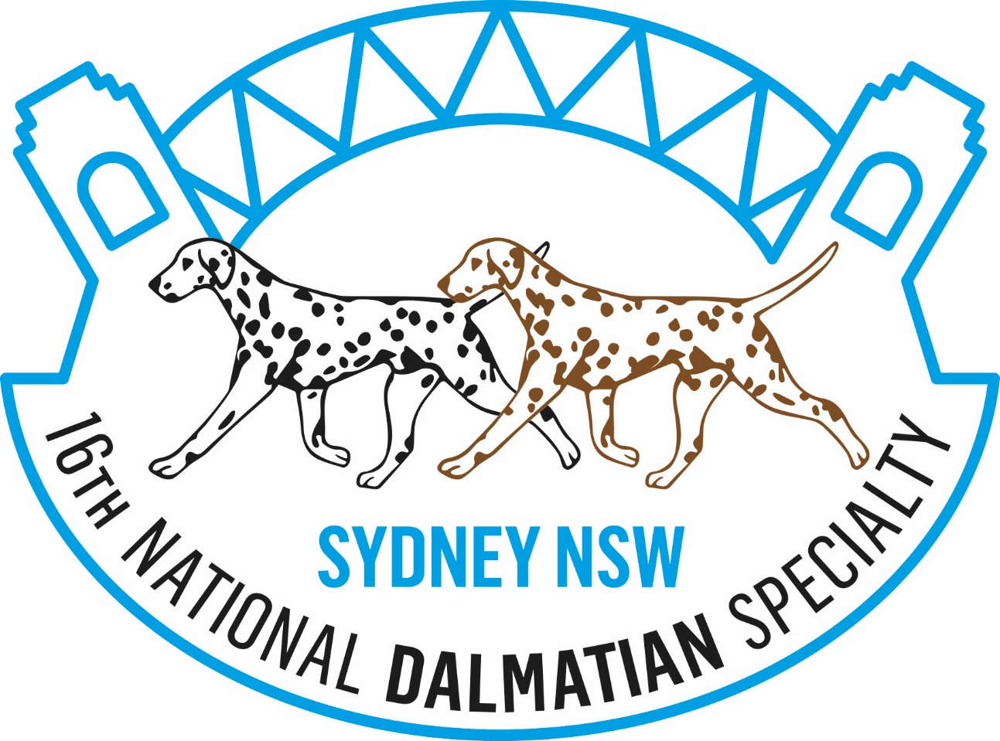



**Venue**: Bill Spilstead Complex for Canine Affairs

44 Luddenham Road, Orchard Hills, NSW

**CHAMPIONSHIP SHOW**

**Saturday 13th October 2018**

**Judge**: **Mrs. L’Udmila Fintorova,**

**“Plum Pudding” Dalmatians, Bratislava, Slovakia**

For information please contact Show Secretary,

Mrs. C Bartley Email: cbartley1@hotmail.com

**OBEDIENCE, AGILITY & RALLY O TRIALS**

**Sunday 14th October 2018**

**Judges:**

**Obedience: Mr. T. Griffin (NSW)**

**Agility/Jumping: Ms. J. Comber (NSW)**

**Rally O: R. Probert (NSW)**

For information please contact Trial Secretary,

Ms S. Whymark Email: speklan@bigpond.com

**16TH NATIONAL DALMATIAN SPECIALTY**

**Hosted By**

**The Dalmatian Club of NSW Inc**