Canine **2018**

6-8 July 2018

Exhibition Park in Canberra

**International**

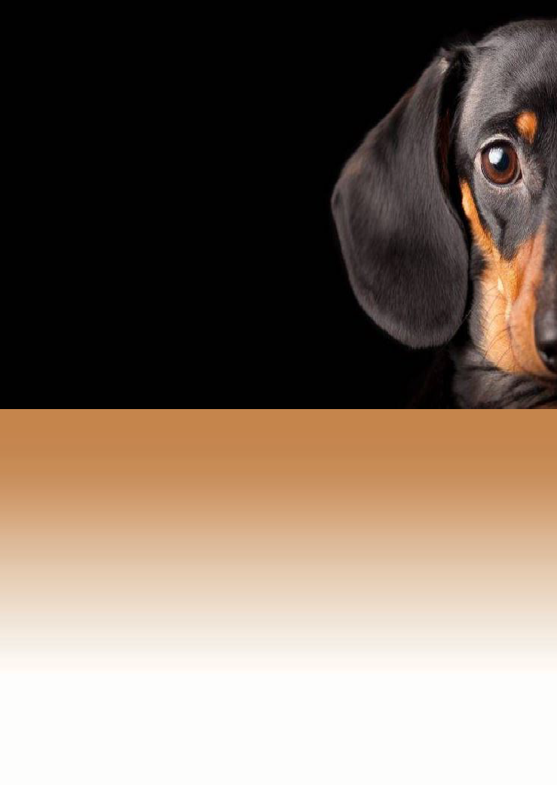

Extravaganza

Exhibitors Booklet - Conformation 2018

*Hosted by*

**EPIC ADVANCE DOG SPORTS EXTRAVAGANZA 2018 – THE EVENT**

Exhibition Park in Canberra is the ACT’s largest multi-purpose centre for events and on this weekend, it will be delivering most of the dog sports on show in Canberra and surrounds for the Canberra community, interstate exhibitors/visitors and international officials.

The information contained in this information booklet is for the benefit of **ALL** exhibitors attending the EPIC Advance Dog Sports Extravaganza (Canberra) hosted by Dogs ACT 5th to 8th July 2018. Part 1 is for the Conformation Exhibitors and Part 2 is for the Dog Sports Exhibitors.

**Overview**

The EPIC Advance Dog Sports Extravaganza is a multi-disciplinary canine event that attracts more than 3,000 dog lovers from the Canberra region and exhibitors from every State and Territory of Australia.

It is the only event in the ACT which brings together the Canberra community who are both dog lovers and active dog owners in the one place over three days where everyone can view and take part in some of the events available. It will be the centre of all canine activities between 05-08 July 2018.

An event such as this brings in thousands of interstate and international exhibitors, officials and visitors. Accommodation, food, and many other facilities are used over the week before this weekend and the week afterwards. These would include banks, petrol stations, grocery stores, all vehicle outlets, veterinarians, medical services, as well as all the tourism attractions that Canberra has to offer.

There is a team of official photographers and DOGS ACT advertises the event on all social media outlets as well as radio, tv and the print media.

**Results**

To date the ‘Extravaganza’ has increased exponentially since its inception. Numbers of exhibitors increased in 2017 by 10 per cent on the previous year, visitors by 20 per cent, and facilities required by approximately 15 per cent.

It is supported by the ACT Government by the use of the EPIC facilities and this brochure identifies all the information required by EXHIBITORS to enjoy their stay in the national capital ¬ Canberra.

**2018 Event Details**

**Venues** Budawang Pavilion, Coorong Pavilion, Conference Centre, Fitzroy Pavilion, Mallee Pavilion, Snowy River room, and the EPIC Main Arena

**Dates** *Thursday 5 July 2018* – Terrier National Championship Show –terrier breeds only – Budawang Pavilion only

*Friday 6 July 2018* – Championship dog shows – all breeds & group specialties

*Saturday and Sunday 7/8 July 2018* -Championship dog shows all breeds & group specialties, Agility competitions, Flyball Competitions, Scent-work demonstrations, Up Dog competitions

**Times** Starting times will vary dependent on the activity underway – a timetable for conformation is included in this booklet.

**Exhibitors In** Friday 6 July 2018 not before 6am (Terriers ONLY will be allowed to set up Thu 5 July if competing in the Terrier National)

**Exhibitors Out** Sunday 8 July 2018 between 4pm to 6pm

**Admission** Free entry to grounds. Exhibitors must pay relevant entry fee per dog for each show.

**Gates** Gates to EPIC are closed overnight. **Gate 4** next to Caltex service station will be opened not later than 6.30am each day. **Gates may be opened earlier if an authorised person with a key arrives early.** Please be considerate to others.

**Rings** Ring allocation: *Coorong Pavilion* – Gundog & Utility Groups.

General Specials will be held in Coorong Pavilion on all 3 days.

Ring allocation: *Budawang Pavilion*: Toys, Terriers, Hounds, Working, Non-Sporting Groups

**Tickets** Tickets, challenges & catalogue collection will be at the front office next to front door of the Conference Centre (bit between Coorong & Budawang Pavilions). Remember catalogues are available **online** **free** but if you want a paper one it had to be ordered with entries. This window will be open from 8am each day. Challenge certificates will be available at the conclusion of the group judging, an announcement will be made when ready for collection. Please note that cc writers have a lot more work on Fri & Sat so please be patient if waiting for your challenges.

**Photos** All group placed exhibits are to be photographed by Ingrid Matschke at her photography stand immediately after the conclusion of group judging. Have a slip signed, stating this has been done, **before** you collect your awards. There will be NO photography in the Rings.

We require all BIG, BIG2, BIG3, BIG4, PIG & BPIG winners to go to this photographic area/podium for the All Breeds shows.

This becomes the BIS, RuIS & all classes in Show for the Fri/Sat group specialties after which the same routine applies.

**Vendors** All vendors will be sited within the Kakadu/Daintree room which is located between the 2 main buildings (Budawang/Coorong) within the Conference Centre. This gives you the opportunity to take advantage of their wares within the same area while remaining warm. Please support your vendors. We have the following vendors: Best In Show, DogSwim, Puddleby Art, Plush Puppy, Top Dog Crates, Marellan Show Ribbons, Kellandy, &

**Sponsors** We have given our great sponsors their own page (in this booklet) as without them we would not have the amazing awards and excellent ribbons that you are awarded over the weekend.

**Questions** If you have any questions please ask one ofthe Dogs ACT representatives walking through the buildings; they will be identified by their hi-vis vests.

# **SPONSORS**

DOGS ACT would like to thank the following sponsors and donating businesses who make these events possible.

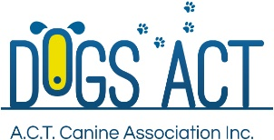

D:\Users\cr0010\AppData\Local\Microsoft\Windows\Temporary Internet Files\Content.Outlook\DO822I6C\image003 (5).jpg

   

  

# **GENERAL INFORMATION**

# **Shopping**

Dickson shopping Centre is located a short drive (5 minutes) down Northbourne Avenue towards the city. The shopping Centre offers a variety of take away food outlets, Woolworths supermarket, along with a bakery and petrol station. Canberra’s Chinatown is located within Dickson shopping centre and all Asian nation eateries can be located there along with many other restaurants.

# **Eateries on the weekend**

Food will be available at the event provided by EPIC in a cafe in the Budawang Pavilion. They will be there from Thursday 5th July to Sunday 8th July. They open at 7am and close at 4pm, unless demand dictates otherwise. McDonalds is also available opposite the Dogs ACT show rings; and there will be a mobile van selling coffee& soup on the Main Arena. All others can be located at the closest shopping centre at Dickson.

# **Camping**

Powered and unpowered sites are available at EPIC. Camping is available 200m from the pavilions at Wagtail Way EPIC (Exhibition Park in Canberra). To book camping sites please contact EPIC on (02) 6205 4976 or email [campingepic@act.gov.au](mailto:campingepic@act.gov.au). Please advise which discipline you are coming for so they know which area to get you as close as practicable to your desired choice. Costs are $35 p night for 2 persons powered site; $30 p night unpowered site. Extra person is $5 p night. Call in to EPIC office at Gate 2 or pay by phone prior to arrival.

Caravans can be hired through B&V Caravans (02) 6299 1101 or Caravan Connections 0417 266 921.

Bookings for caravans should be made directly with them and not Dogs ACT or EPIC.

# **Contact Details**

Further enquiries and questions can be directed to the Dogs ACT officials in hi-vis vests on each day.

Dogs ACT welcomes you to this 3/4-day spectacular. We hope you enjoy your sport and come back next year when we hope it will be bigger and better.

All information relating to the conformation shows can be found on our [**website**](http://www.dogsact.org.au) at the tab **July 2018**

**Other Information**

**MEDIA** -there will be various outlets of the media present during the 4 days of the Extravaganza. They are here to view the shows and make favourable comments about our dogs and it would be appreciated if you could be courteous to them all as good publicity is paramount for our disciplines. We will have present the print media, social media commentators, radio stations and the local television station, should you be asked to comment. If you have comments noted please advise one of the Dogs ACT staff and let them know which part of the media – this is in order to obtain copies of printed material to post on and after the weekend.

**Facebook** – www.facebook.com Epic Advance Dog Sports Extravaganza 2018 and also at Dogs ACT – Canberra general facebook page. There is also a specific page for the Terrier Group National Championship Show.

An **ATM** machine will be set up inside the entrance to the Conference Centre which is located between the Budawang and Coorong Pavilions. It will be set up at 8am Thursday 5th July and closed off at 6pm each night so will be unable to dispense cash between 6pm and 8am the following day.

A **map** of the EPIC showground is attached at the end of this document for your information showing the location of each sport/event in 2018.

**Raffle** – a grand raffle will be available all weekend. Tickets are available prior to the weekend on Show Manager or when in Canberra at the events. The raffle will be brought around to all disciplines. Tickets are $2 ea or $5 for 3 tickets & $10 for 7 tickets. Prizes are a large trolley, large crate, dog food, dog grooming products and more.

**Note** - The general public will also be able to visit your sports and Dogs ACT are making Saturday 7th July an Open Day for the public. Please make them welcome where you can but please be mindful that your dogs and their competition is your primary concern.

**CONFORMATION**

**INFORMATION**

**CONFORMATION** - **TIMETABLE**

|  |  |  |
| --- | --- | --- |
| **ACCESS TIMES** | **CONFORMATION** | **DESCRIPTION** |
| **Thursday 5th July** | | |
| 6.00am | Budawang Pavilion | **Pavilion Open** - Terriers set up **ONLY** |
| 8.00am | Between Budawang & Coorong Pavilions | ATM machine installed inside building |
| 9.00 am | Budawang Pavilion | Start of Terrier National – all day show |
| 9.00am | Conference Centre Main reception | TERRIER Catalogue only available & queries |
| **Friday 6th July** | | |
| 6.00am | Budawang & Coorong Pavilions | **Both Pavilions Opened - All** Exhibitors can set up |
| 7.30am | Conference Centre  Main reception | Office Open for catalogues & queries |
| 8.30am | Budawang/Coorong | All breeds show – all rings commence |
| 12.30 pm | Coorong Pavilion main GS ring | Official Opening by ACT Minister accompanied by Embassy/High Commission Officials |
| 1.00pm or after | Budawang/Coorong | Group only shows - all rings commence |
| **Saturday 7th July** | | |
| 6.00am | Budawang/Coorong | Exhibitor set up |
| 7.30am | Conference Centre | Office Open for catalogues & queries |
| 8.30am | Budawang/Coorong | All breeds show – all rings commence |
| 1.00pm or after | Budawang/Coorong | Group only shows - all rings commence |
| **Sunday 8th July** | | |
| 6.00am | Budawang/Coorong | Exhibitor set up |
| 7.30am | Conference Centre Main reception | Office Open for catalogues & queries |
| 8.30am | Budawang/Coorong | All breeds show – all rings commence |
| 3.30pm | Budawang Pavilion | Canteen closes |
| 4.00pm | Between Budawang & Coorong Pavilions | ATM Machine removed |
| **6.00pm** |  | **All Pavilions locked down** |

# **Parking and Entry Provisions**

There is plenty of easy free parking for cars, trailers and RV’s close to all event disciplines.

Entry to the events will be via **Gate 4,** EPIC; come in **via McDonalds**, turn left and follow the signs.

**Conformation** trailer parking only will be in Magpie Park – bonnets facing towards road. Trailers will not be permitted to park outside Budawang or Coorong pavilions. These spaces are for cars only without trailers.

**NOTE**: *It was noted at the 2017 conformation events that some exhibitors wanted to spoil the event for others by ignoring the parking signs and Dogs ACT staff and parking with trailers outside the building they wanted to get to. While we appreciate that you will need to unload, once completed please put your car + trailer into the correct car park.*

# **Documentation Hubs**

The Documentation Hub for the Conformation shows will be located between the two conformation pavilions (Budawang & Coorong). Catalogues, numbers and Challenge Certificates can be collected from this office via the front counter (Conference Centre). Trophies to be collected at ringside. Please take your exhibit number to Hub to collect certificates as none will be given out without tickets. Please do NOT collect on behalf of others as no replacement certificates will be made.

The Documentation Hub for the Agility competitions will be at ringside on the Main Arena. All documents for Flyball, Scent-work and Disc dogs will be handed out from the secretary’s area in the relevant pavilion or Main Arena.

***CANOPIES*** will **not** be allowed within the pavilions and no spaces are permitted to be ‘saved’. This will be policed throughout the weekend and we ask that you be aware that indoor events have *limited* space. Be considerate not selfish!

***Generators*** will not be permitted to be used within the pavilions. There will be a designated grooming area outside where you can use power for your generator.

Any ***electrical*** equipment MUST be tagged and any found not tagged will be removed.

**Petrol**

Petrol, diesel and gas can be obtained at the Caltex service station at Gate 4. The next nearest service station is located within the Dickson shopping centre where there are at least 3 of them.

# **CONFORMATION JUDGING**

Conformation judging will be held in the Coorong and Budawang Pavilions over 3 days. Judging will commence daily at 8.30am. All rings will be judged simultaneously in group order with part A being judged before part B where necessary and with General Specials for All Breeds shows in the Main Ring in the Coorong Pavilion. Group Specialties will conduct their Specials in their individual Group Rings.

**TERRIER GROUP CH SHOW:** Classes to be judged are1, 2, 3, 4, 5, 10, 11 & 18 Dogs and Bitches **Thursday 5th July9am start**

**ALL BREEDS SHOWS**: Classes to be judged are 1, 3, 4, 5, 10, & 11 Dogs and Bitches

**GROUP SPECIALTY SHOWS:** Classes to be judged are1, 2, 3, 4, 5, 10, 11 & 18 Dogs and Bitches

***Floor surfaces*** will be carpeted. Please be mindful of where your dogs are toileting and clean up after them. Dogs should be toileted **outside** the pavilions and it is your responsibility to pick up after your dog with the bags and bins provided.

***Canopies*** will not be allowed within the pavilions and no spaces are permitted to be ‘saved’. This will be policed throughout the weekend and we ask that you be aware that indoor events have *limited* space.

***Generators*** will not be permitted to be used within the pavilions. There will be a designated grooming area outside where you can use power for your generator.

Any ***electrical*** equipment MUST be tagged and any found not tagged will be removed.

# **AWARDS – 3 ALL-BREED SHOWS**

**Group Awards** will be for Best in Group 1, 2, 3, 4 - Baby in Group, Puppy in Group

**General Specials Awards** will be for Best in Show 1, 2, 3, 4 - Baby in Show, Puppy in Show

Challenge Certificates can be collected from the Documentation Hub on presentation of your exhibit number/s. All winners are to take their ribbon and dog for photographs immediately after Group judging and General Specials judging to the official photographer’s stand. This will be set up in the Coorong Pavilion next to the General Specials ring. There will be NO pictures allowed within the rings.

**AWARDS** - **2 SPECIALTY SHOWS**

These will be given for all classes of Best in Show 1, 2, 3, 4, 5, 10, 11 & 18

Challenge Certificates can be collected from the Documentation Hub on presentation of your exhibit number/s. All winners are to take their ribbon and dog for photographs immediately after General Specials judging to the official photographer’s stand. This will be set up in the Coorong Pavilion next to the General Specials ring. There will be NO pictures allowed within the rings.

**AWARDS -TERRIER GROUP NATIONAL SHOW**

These will be given for all classes of Best in Show 1, 2, 3, 4, 5, 10,& 11. There will separate awards for best short legged, long legged & bull breed terriers. Additional awards will be given for every Best of Breed.

**JUDGES**

# Mr Geir FLYCKT-PEDERSEN (USA)

# Mag Gerhard POLLINGER (AUSTRIA)

Mr Joe NAGEL (SOUTH AFRICA)

Ms Leyda Lucia PEREZ (COLOMBIA)

Mr Antonio DALLE PIAGGE (BRAZIL)

Mr Demetris CHRISTODOULOU (CYPRUS)

Mr Norman DESCHUYMERE (BELGIUM)

Mr Hitoshi SAYAMA (JAPAN)

Ms Monika BLAHA (AUSTRIA)

Mr Alex ROJAS (MEXICO)

# **Pavilions**

Both Budawang and Coorong Pavilions are indoor areas and are carpeted for your comfort. Care should be taken when walking around the rings within the pavilions. Responsibility for your children is yours - please ensure their safety, for example running should be discouraged.

Pavilions will be heated to a comfortable temperature for dogs and people.

It is also your responsibility to ensure that you clean up after your dogs should they accidently toilet on the pavilion carpet. Bags and washing materials will be provided. Please contact a DOGS ACT representative who will provide the materials necessary.

**Free Wi-Fi** will be available for exhibitors within the pavilions.

# **Official Photographer**

Photographs will be taken by the official photographer, Ingrid Matschke Photography and Team. A Photography Stand will be available for official photos which will be next to the General Specials ring in the Coorong Pavilion. Should you wish to purchase a photograph please speak with the photographer on the day; she will have business cards with her to contact after the events.

**Please note: All winners are to take ribbons and dog for photographs immediately after Group judging and General Specials judging to the stand ONLY. There will be no photographs taken in the judging rings.**

There will likely be a queue however all judges have been advised that no photographs are to be taken in the judging rings and we appreciate your patience. No one will miss out or miss their calls.

**Junior Handlers**

Will be held during the lunch break on Sunday 8th July 2018, commencing at 12.30pm.

# There is no entry fee for junior handler classes with 2 classes on offer - age 7yrs and under 12yrs also 12yrs & under 18yrs.

**Veterans Grand Parade**

Will be held at 8.30am on Friday 6th July 2018 and is a non-competitive event.

It will showcase the veterans of our canine world. A short bio on each entrant will be read out as the dogs are presented. All bios MUST be with the DOGS ACT office no later than Friday 29th June 2018.

# **First Aid**

If an accident or health problem occurs please contact immediately one of the Dogs ACT event organisers, they will be wearing hi-vis vests at all events with the words Dogs ACT on them. First aid kits will be available for minor issues but ambulances will be called for more serious injuries or incidents.

**Official Opening**

There will be an official opening at 12.30pm on Friday 6th July 2018 only. It will be conducted by Dogs ACT and a Minister from the ACT Government and will be witnessed by Diplomats from the relevant Embassies and High Commissions of countries from which the judges originate. It will also be a media opportunity and you should expect some heightened awareness of the events on that day and the whole weekend.

**EPIC Advance Dog Sports Extravaganza 2018 – All Events**

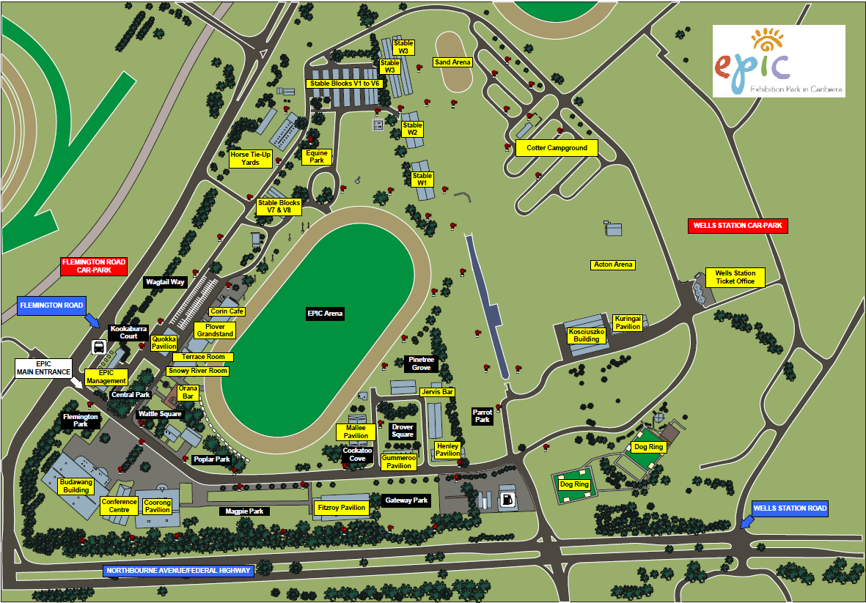

|  |  |  |
| --- | --- | --- |
| **Event** | **Venue** | **Parking** |
| Championship Shows | Coorong Pavilion  Budawang Pavilion | Cars only outside both buildings. Trailers in Magpie Park only |
| Agility | EPIC Main Arena | On the sand track around Main Arena  To get there – come in past McDonalds, turn left & then right at snowy River Room into Arena. NO parking on grass |
| Flyball | Fitzroy Pavilion | Outside Fitzroy – Camping in Gateway Park |
| Scentworks | Mallee Pavilion | Outside Mallee |
| UpDog | EPIC Main Arena | Same as Agility |
| Camping | Wagtail Way | All disciplines except Flyball campers. Camping office is in EPIC management office |
| Catering | Budawang Pavilion  EPIC Main Arena | Indoor Café – Thu-Sun  Mobile Van Sat/Sun |
| Competitors Entrance | Gate 4 | Do not use EPIC main entrance. Roadworks making access difficult. From Northbourne Ave, turn left at Caltex petrol station/McDonalds. Turn left continue down internal road |