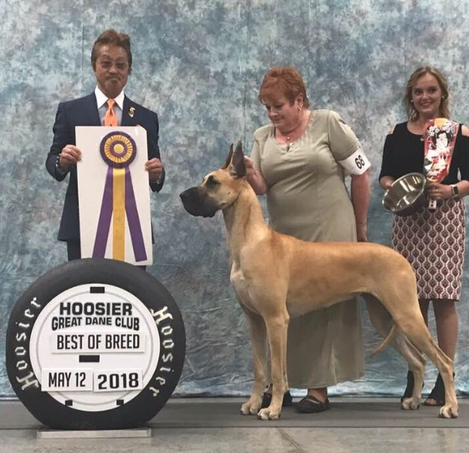

Hitoshi Sayama

I was born in Tokyo in 1959 where my mother was a great dog lover. As a child growing up my family had Collies, Boxers, Bulldogs Akitas, Poodles, Pekingese, Pomeranians, Chins, Maltese, and Yorkshire Terriers.

I attended dog shows with my mother and from the beginning always wanted a Great Dane. My parents did not allow me to have one due to the town limits and my time requirements. So, when I was 22years old I moved to the countryside from Tokyo where I got my own place. My search for a Great Dane began and in 1984 my dream was realized.

My first Great Dane was a fawn bitch which was the beginning for D.S.S. King’s Ransom kennel.
I came to visit the Great Dane Club of America National Specialty for the first time in 1989. Since then I have only missed one National in the 28 years from 1989 to 2016.
I have been a professional handler between 1979 and 2009. I have produced more than 50 JKC, FCI and American Champions. I got married in 1990 and my wife’s special breed is the Kerry Blue Terrier and she also shows poodles.
My breeding brindle color bitch, D.S.S. King’s Ransom JP Berlinetta has obtained the following awards: Best in Specialty Show Great Dane Club of America National in 2001; An Award of Merit in 2002 and Best in Show and Top 20 of the Year in 2003.

I got my first judges license in 1998 becoming an all breeds judge in 2009. I have judged in Japan many times and overseas in many other countries including America, Ireland, Korea and Mexico.

