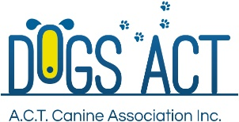

**DOGS ACT EPIC ADVANCE DOG SPORTS EXTRAVAGANZA 2018**

**SCENT WORK GAMES**

**7-8 JULY 2018**

**Check-in: 9.30 am**

**Briefing and walk-through commences: 10 am**

**Judging commences: 10.15 am**

**Trial Manager: Julie Cutts (jarrah236@gmail.com)**

|  |  |  |  |  |  |
| --- | --- | --- | --- | --- | --- |
| **Judge** | **Element** | **Venue** | **Comp** | **NFC** | **Paired** |
| **Saturday, 7 July 2018** | | | | | |
| Peta Clarke | Containers | Mallee Building | 22 | 4 | 1 |
| Angela Hervey-Tennyson | Vehicles | Adjacent to Mallee Building |
| **Sunday, 8 July 2018** | | | | | |
| Peta Clarke | Exteriors | Adjacent to Mallee Building | 17 | 3 | 0 |
| Angela Hervey-Tennyson | Interiors | Mallee Building |

Scent Work Games is not currently an ANKC sport. The games will be conducted using the rules set out in the ACSW K9 Nosework Rule Book (the entry level ie Nosework 1). The games are not being conducted by, nor do they have anything to do with, the ACSW.

Judging Order: Both elements simultaneously

Sashes for 1st, 2nd and 3rd places in each element.

Please notify the Trial Manager of any errors in your catalogue entry.

**DOGS ACT EPIC ADVANCE DOG SPORTS EXTRAVAGANZA 2018**

**SCENT WORK GAMES**

**CATALOGUE – RUNNING ORDER**

**10am, Saturday, 7 July 2018**

**Judge: Ms Peta Clarke Containers (Mallee Building)**

**Judge: Ms Angela Hervey-Tennyson Vehicles (adjacent Mallee)**

|  |  |  |  |
| --- | --- | --- | --- |
| **No** | **Handler** | **Dog** | **Level** |
| **1** | Julie Cutts | Elliott (Ch Hillmagic Black Shiraz) | Competition |
| **2** | Rhonda Daley | Gryffin (Hillmagic Golden Snitch) | Competition |
| **3** | Niccola Hardaker | Zim (Ch Llandwyn Crescent Moon) | Competition |
| **4** | Jenny O’Connor | Kobe (Eraky Kobe) | Competition |
| **5** | Graeme Fenmore | Wiggles | Competition |
| **6** | C Stani | Daenerys Rider on the Storm | Competition |
| **7** | Laraine Frawley | Cam (Twigworth Jasper) | Competition |
| **8** | Sue Turner | Enya (Ch Ciganyoz Enya) | Competition |
| **9** | Leanne Holgate | Izzy | NFC |
| **10** | Natasha Neppi | Tari | Competition |
| **11** | Debra Lemanski | Delilbra I’m Your Huckleberry | Competition |
| **12** | Joshua Hathaway | Tenarda Mystery Maker | Competition |
| **13** | Tracie Donnelly | Gamester Crime Scene | Competition |
| **14** | Janet Speed | Ty | Competition |
| **15** | Helen Voyce | Bohunt Take A Back Seat | Competition |
| **16** | Naarilla Hirsch | Kishar (Gadhar Kishar) | Competition |
| **17** | JF Barnett | Ch Cornstalk Nogood Boyo | Competition |
| **18** | Cheryl Neal | Mya (Ch RowenGlen Gurlesque) | Competition |
| **19** | Kate Johnson | Billy | Competition |
| **20** | Jess Buckley | Ch Stylwise Dizzee Rascal | Competition |
| **21** | J Vandenbroek | Lila | Competition |
| **22** | Dorothy Xu | Chad | Competition |
| **23** | Jenny O’Connor | Chilli (Goldtreve Sweet Chili) | NFC |
| **24** | Angela Hagedorn | Eweturn Knight Errant | Competition |
| **25** | Niccola Hardaker | Inari (Ch Sarasota Vanilla Cola) | NFC |
| **26** | Naarilla Hirsch | Arcus (El’shamah Arcus) | NFC |
| **27** | Di Adams | Ernie | Paired (NFC?) |

**DOGS ACT EPIC ADVANCE DOG SPORTS EXTRAVAGANZA 2018**

**SCENT WORK GAMES**

**CATALOGUE – RUNNING ORDER**

**10am, Sunday, 8 July 2018**

**Judge: Ms Peta Clarke Exteriors (adjacent Mallee)**

**Judge: Ms Angela Hervey-Tennyson Interiors (Mallee Building)**

|  |  |  |  |
| --- | --- | --- | --- |
| **No** | **Handler** | **Dog** | **Level** |
| **1** | Julie Cutts | Elliott (Ch Hillmagic Black Shiraz) | Competition |
| **2** | Rhonda Daley | Gryffin (Hillmagic Golden Snitch) | Competition |
| **3** | Niccola Hardaker | Inari (Ch Sarasota Vanilla Cola) | Competition |
| **4** | Jenny O’Connor | Kobe (Eraky Kobe) | Competition |
| **5** | Graeme Fenmore | Wiggles | Competition |
| **6** | C Stani | Daenerys Rider on the Storm | Competition |
| **7** | Laraine Frawley | Cam (Twigworth Jasper) | Competition |
| **8** | Sue Turner | Enya (Ch Ciganyoz Enya) | Competition |
| **9** | Angela Hagedorn | Eweturn Highland Fling | Competition |
| **10** | Natasha Neppi | Tari | Competition |
| **11** | Debra Lemanski | Delilbra I’m Your Huckleberry | Competition |
| **12** | Joshua Hathaway | Tenarda Mystery Maker | Competition |
| **13** | Tracie Donnelly | Gamester Crime Scene | Competition |
| **14** | Helen Voyce | Bohunt Take A Back Seat | Competition |
| **15** | Naarilla Hirsch | Arcus (El’shamah Arcus) | Competition |
| **16** | Kate Johnson | Billy | Competition |
| **17** | Airlie White | Kerodan Badjas Drift | Competition |
| **18** | Jenny O’Connor | Chilli (Goldtreve Sweet Chili) | NFC |
| **19** | Niccola Hardaker | Zim (Ch Llandwyn Crescent Moon) | NFC |
| **20** | Naarilla Hirsch | Kishar (Gadhar Kishar) | NFC |

**Competitor Information**

**General Public**

The general public are invited to attend the Extravaganza which is intended to showcase dog sports to the ACT and region community. Saturday, 7 July 2018 is considered the ‘open day’ when the majority of the public will come through. While they are encouraged to leave their dogs at home given the number of dogs competing at the event, Dogs ACT cannot refuse people bringing their dogs to EPIC.

Spectators will be permitted in a spectator area of the search areas during the games. No dogs will be allowed in the search area (other than the competing dog) or the spectator area.

**Managing your dog**

Competitors’ dogs should be on lead at all times while at the Extravaganza. There are no off-lead exercise areas at the venue.

Please be respectful of other competitors and their dogs as they move around the venue area and keep a reasonable distance between you. If your dog is reactive, and you would like to park in a quieter area, please contact the Trial Manager ([jarrah236@gmail.com](mailto:jarrah236@gmail.com)).

Dogs and handlers must stay in designated areas to avoid contaminating the search area, interrupting a test underway, or from viewing part of the search.

The dog's owner is responsible for having their dog ready when it is to be judged. Be prepared to keep your dog in your car or in a crate by your car when not being tested. You are responsible for picking up after your dog.

Bitches in season cannot participate in the games.

**The Games**

**Searches are usually conducted on lead. The exception may be (at the discretion of the judge), the interior element.**

**1st, 2nd and 3rd placings will be provided for each element.**

**Acknowledgments**

OFFICIAL PHOTOGRAPHER: Ingrid MATSCHKE Photography and her team ONLY

Many thanks to the following people for their assistance with the games:

John Sam; Mick Medson; Suzy Whymark; Janet Speed; Juliet Ward; Steve Dempsey; Jo Washinton-King; Sophie Dunstone; Jan Loose

Refreshments (sausage rolls, soup, sandwiches, hot and cold drinks) available to purchase on the Main Arena or in the Coorong/Budawang Buildings.

Many thanks also to Canberra Nosework Training and K9Pro for their donation of prizes for the games.

# **SPONSORS**

DOGS ACT would like to thank the following sponsors and donating businesses who make these events possible.

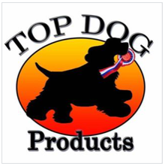

D:\Users\cr0010\AppData\Local\Microsoft\Windows\Temporary Internet Files\Content.Outlook\DO822I6C\image003 (5).jpg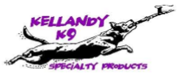

  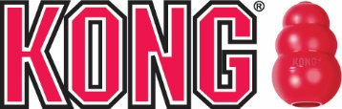  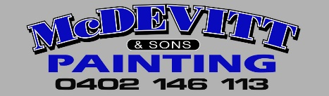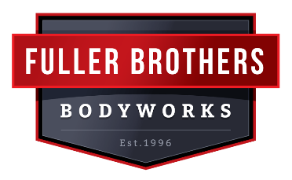 

 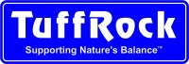 

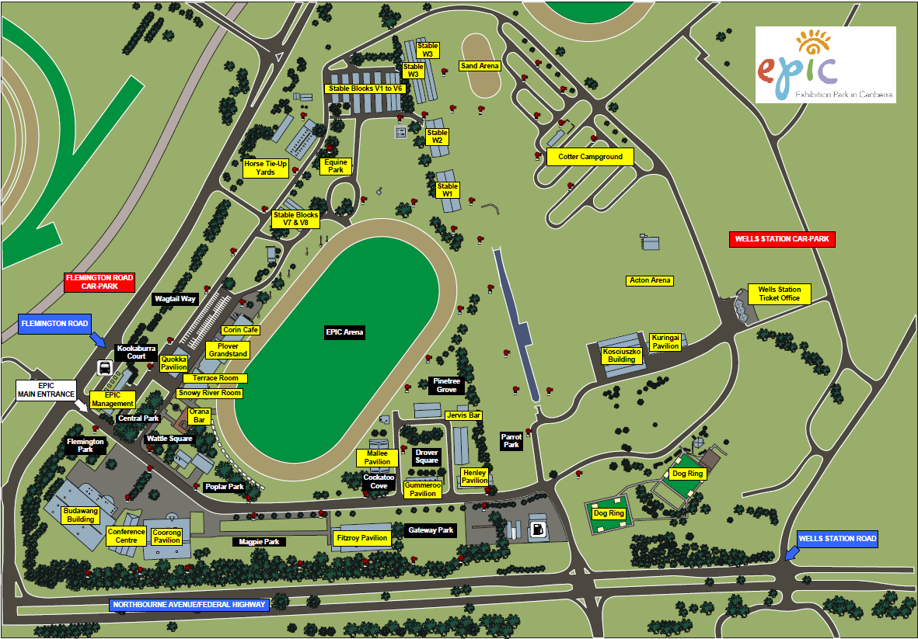

Agility

UpDog

Scent works

**Entry to Parking by Exhibitors**

Flyball

Trailer Parking only

Dog shows

Shows entrance

Dog shows

**McDonalds**