ENTRIES CLOSE: 12 January 2019 (no late entries)
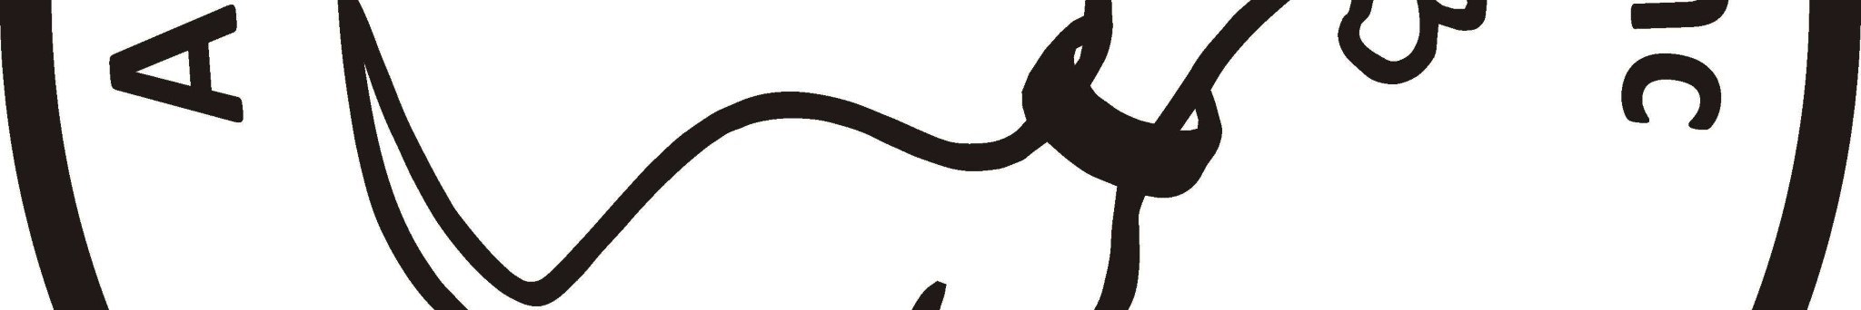

ACT COMPANION DOG CLUB
DOUBLE RALLY OBEDIENCE TRIAL

Saturday 19 January 2019
Venue:
ACT CDC grounds, 240 Narrabundah Lane, Symonston ACT 2609

Trial 1 – Ms Julie Cutts (ACT)
Trial 2 – Mr Sid Schuck (ACT)
Novice
Masters
Advanced A & B
Excellent A & B
Excellent A & B
Advanced A & B
Master
Novice

Trial 1 commences: 6.00 pm

Check-in:
5.15 pm– 5.45 pm
Printed catalogue
$2 or free by email
Entry fee:
S11 per individual class, or $20 per
dog for RAE (combined entry of Adv/Exc B)

Trial 2 commences: 6.00pm

Check-in:
5.15
pm – 5.45 pm
Printed catalogue
$2.00 or free by email.
Entry fee:
$11 per individual class, or $20 per
dog for RAE (combined entry of Adv/Exc B)

OR Pay CDC entries direct online –
BSB: 032-729, Account Number: 235628, Reference: RO2001 (for Rally-O) + Your surname +
phone number; or by cheque/money order. PLEASE DO NOT SEND CASH THROUGH THE MAIL

NOTE:
Catalogue for the trial is available FREE via email no earlier than 3 days before the trial.
Please provide email address with entries.

NEW
- Dogs ACT Regulation: Judges may compete provided they do not do so in classes they have
been contracted to judge
The Club reserves the right to amend the judges and judging order should the entries require.

Entries to:
Rally Obedience Trial Manager, ACT Companion Dog Club,
PO Box 4048,
Kingston ACT 2604
Phone: 6295 7764 (10-2pm, Tuesday-Friday)
Email:

blue201dog@yahoo.com.au
(enquiries only. Emailed entries will not be accepted, all entries
to be on approved ANKC Obedience entry forms, separate form for each trial)
Awards:
Sash for 1
^{st}
, 2
^{nd}
and 3
^{rd}
place getters (Qualifying scores only). Sash for titles gained on the
day.

