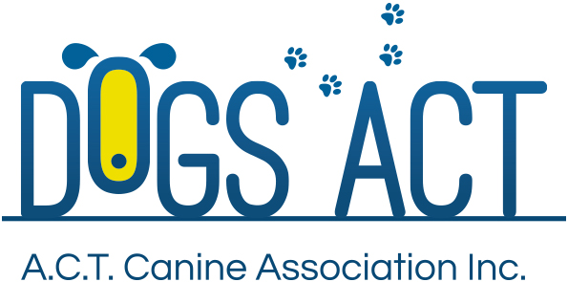
Terrier Group Shows
Saturday 13th and Sunday 14th April 2019
THESE SHOWS TO BE HELD IN CONJUNCTION WITH
ACT & DISTRICTS STAFFORDSHIRE BULL TERRIER CLUB SHOWS
AND TOY DOG CLUB & CAVALIER CLUB TOY GROUP SPECIALTY SHOWS
Exhibition Park in Canberra, Federal Highway, Canberra
Classes: 1, 2, 3, 4, 5, 10, 11 & 18 (dogs & bitches)

Saturday 13th April 2019
Judging commences 8:30 with:
Ms Ginette Loft (NSW) - Staffordshire Bull Terriers – BITCHES FIRST
followed by MRS DI CROSS (NSW) – Bull Terriers & Bull Terriers (Miniature)
followed by Mr Reece Fry (Qld) – Balance of Terriers, alphabetically,
then General Specials

Sunday 14th April 2019
Judging commences 8:30 with:
Ms Kerry Hellsten (Vic) - Staffordshire Bull Terriers – DOGS FIRST
Followed by Balance of Terriers, alphabetically, & General Specials

Trophies Trophy and sash
Best of Breed Staffordshire Bull Terrier $50 cash
Entry Fees: $13.00 per class, numbers to be collected at the show.
Remittances: Dogs ACT
Catalogue: $5.00 pre ordered or online only no catalogues available for sale on the day
Entries close: 2nd April 2019 (postal)
9.00am 8th April 2019 (online)
NO REFUNDS AFTER 2nd April 2019
Email enquiries: admin@dogsact.org.au
NUMBER CARDS TO BE COLLECTED ON THE DAY OF THE SHOW
Dogs ACT hot weather policy applies – PH (02) 6241 4404
Entries to: | Show Secretary, PO BOX 815  DICKSON ACT 2602  Ph: (02)6241 4404 (9.30am to 2.30pm Tue, Wed & Thur)  email: admin@dogsact.org.au
Dogs ACT reserves the right to change or reallocate judges as necessary.
Show Committee members do not handle at these shows.
On grounds camping $30 p/day must be Pre-booked and Paid, phone 02 6241 4404
Casual camping $35 p/day.

