EPIC Advance Dog Sports Extravaganza 2019 – Championship Shows, Agility, Flyball,
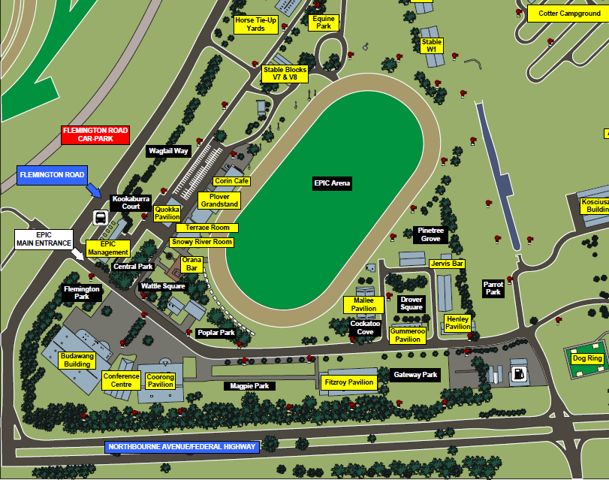
Event | Venue | Parking
Championship Shows | Coorong Pavilion  Budawang Pavilion | Cars only outside both buildings. Trailers in Magpie Park only
Agility | EPIC Main Arena | On the sand track around Main Arena  To get there – come in past McDonalds, turn left & then right at snowy River Room into Arena. NO parking on grass
Flyball | Fitzroy Pavilion | Outside Fitzroy – Camping in Gateway Park
 | Mallee Pavilion | Outside Mallee
Camping | Wagtail Way | All disciplines except Flyball campers  Camping management are in EPIC management
Catering | Budawang Pavilion  EPIC Main Arena | Café  Mobile Van
Competitors Entrance | Gate 4 | Do not use EPIC main entrance. Roadworks making access difficult. From Northbourne Ave, turn left at Caltex petrol station/McDonalds. Turn left continue down internal road

