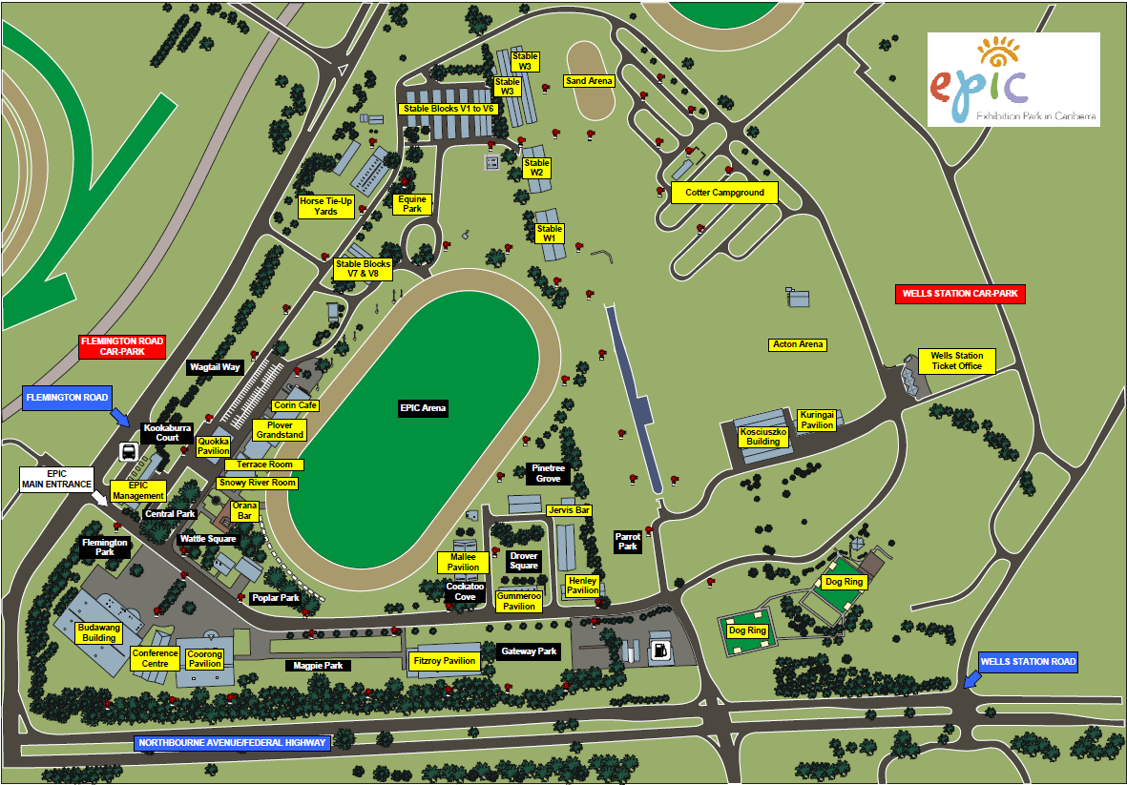

**Entry to Parking by Exhibitors**

**McDonalds**

**Dog Trailer Parking only**

Dog shows

Dog shows

Flyball

Shows entrance

UP Dogs

Obedience, Rally

Agility