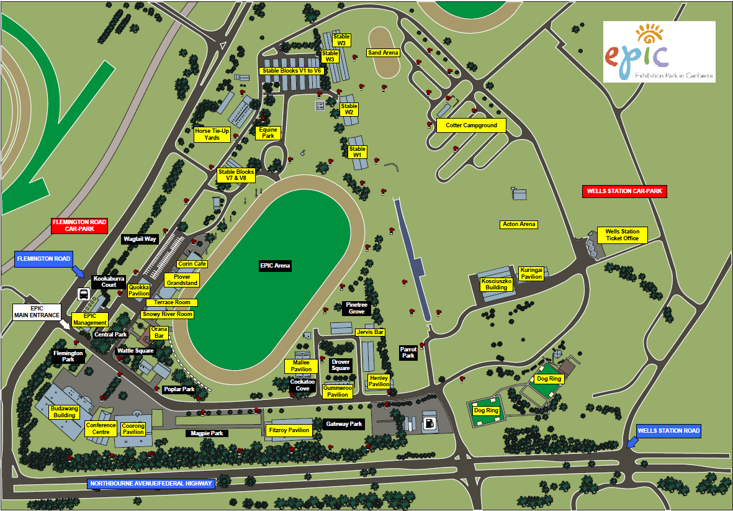

Shows entrance

Dog shows

Dog shows

Obedience, Rally

Agility

UP Dogs

Flyball

Trailer Parking only

Scent works