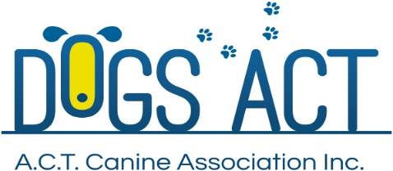
ACT Canine Association Inc. (ABN 11150955611) trading as Dogs A.C.T.
Exhibition Park, Federal Highway, Mitchell, ACT.
PO Box 815, Dickson ACT 2602. Phone 02 62414404.
Email: admin@dogsact.org.au or visit: http://www.dogsact.org.au

APPLICATION FOR A CHAMPIONSHIP OR AWARD.

IMPORTANT - To improve our response time:
- You MUST attach the Certificate of Registration to this application for title or award.
- You MUST include the correct fees with this application for title or award.
- You MUST be able to present the correct cards or certificates relevant to the title or award.
Certificate (includes Breeders Certificate) all disciplines
Grand Championship Certificate (Includes Breeders Certificate)
Supreme Championship Certificate (Includes Breeders Certificate)
Sash
Fees: refer to our website, dogsact.org.au / Forms and Fees
Title or Award applied for:

Breed:
Name of Dog:
Registration Number: |  | Sex:

Owner/s:
Membership Number:
Address:
Phone Number/s:
Email Address:

Where you have applied for a Breeder’s certificate –
Please complete Breeders Name & Address including post code.
Breeders Name:
Breeders Address:
CARD DETAILS:
Visa |  | MasterCard |  |  | Card Expiry Date: | /

 | - |  | - |  | -

Name as per credit card:

Please debit my credit card in the amount of $

Signature/s: | /
Forward your completed application to: “Dogs A.C.T, PO Box 815, Dickson, ACT, 2602”

DETAILS OF QUALIFYING CERTIFICATES:

DATE |  | AFFILIATE’S NAME |  |  | JUDGE | POINTS  AWARDED
Declaration in signing this form:
I/We declare that the above details are correct and in accordance with qualifying certificates now in my/our possession.
I/We agree to have the details of this/these awards published as required from time to time by ACTCA practice and ANKC Regulations
If this application is found to be false in any way, the owner and dog may be subject to disciplinary action including cancellation of the title and disqualification from further events.

Date |  |  | Signature/s: | /

