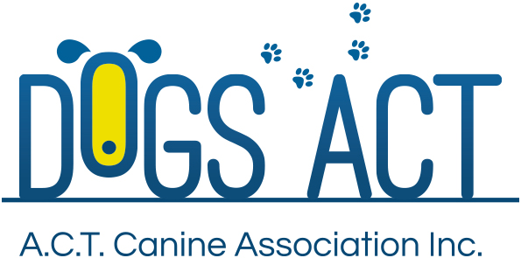
Spring Spectacular Shows
Sunday 6th Oct 2019
Gundog Group Specialty
Open Show
Exhibition Park in Canberra, Federal Highway, Canberra
Classes: 1, 2, 3, 4, 5, 10, 11 & 18 (dogs & bitches)
Held in conjunction with the ACT Gundog Club Specialty Shows (Sat/Sun) and the Dogs ACT All Breeds Show (Mon)

JUDGE
Ms M O’Shannassy (ACT)

Judging commences: NBF 12pm (Following the ACT GDC Champ Show)
Trophies Prize and sash
Entry Fees: $6 all classes
Remittances: Made payable to Dogs ACT
Catalogue: $5.00 pre ordered or online only, no catalogues available for sale on the day
Entries close: 15th Sep 2019 (postal) 9.00am 24th September 2019 (online)
NUMBER CARDS TO BE COLLECTED ON THE DAY OF THE SHOW
Entries to: | Show Secretary, PO BOX 815. DICKSON ACT. 2602  Ph: (02)6241 4404 (9.30am to 2.30pm)email: admin @dogsact.org.au
Dogs ACT reserves the right to change or reallocate judges as necessary.
On grounds camping must be pre-booked, phone 02 6241 4404
General enquiries to the co-ordinator Di Gooding. 0411 283 753.
No calls after 9pm please
Dogs ACT hot weather policy applies – PH 0411 283 753

