DOGS ACT

Track and Search Workshop: 28-29 March 2020

Presenter: Debby Lamprecht, Tracking and Track & Search Judge

Debby Lamprecht is an experienced Tracking and Track and Search Judge in Queensland. She regularly travels to judge and present workshops on tracking, track and search and scent work (see bio below).

In this workshop Debby will introduce the concepts and training methods for transitioning a dog to the ANKC dog sport discipline of ‘Track and Search’. Track and search is ‘urban tracking’, in contrast to tracking which largely occurs in the bush and grassed areas.

Track and Search is intended to be as close as possible to a life-like situation where the dog follows a specific human scent while adapting to changing scenting conditions to find a missing person. Track and Search tests are conducted in urban environments, parklands or other suitably contaminated urban areas.

The dog is required to work on varied surfaces including gravel, sand, paved surfaces, roads and grass. The track may cross small streams or shallow bodies of water, roads and be laid in contaminated areas where there are houses, bridges, shelters, stairs and ramps, parking areas or similar structures. Light vehicle and pedestrian traffic including other dogs walking on lead may also be encountered.

On 1 January 2019, the ANKC supported the separation of the Tracking and Track and Search disciplines which allows dogs to do one or both disciplines. It is not necessary to obtain a Tracking Championship first before commencing in Track and Search.

With the increasing lack of available and suitable tracking land, Track and Search offers trackers with an alternate tracking discipline which can be done in an urban area. This means a longer tracking season as there are fewer concerns about snakes in an urban environment like Canberra.

Date: Saturday/Sunday – 28-29 March 2020

Venue: Dogs ACT
Address: Exhibition Park in Canberra, Cnr of Stirling Ave and Federal Hwy, MItchell

Time: 8am – 4pm – both days

Format: Lectures and practical exercises – draft program attached.

Participation: Working spots: A limited number are available. You must be prepared to attend both days of the workshop as handlers and their dogs will progress exercises from day 1 to day 2. You must also agree to your training exercises being videoed to inform follow-up discussions with workshop participants during the weekend.

Auditing spots are also available

Cost: Working spot $170
Auditing spot $90

Catering: Tea and coffee – provided free
Cool drinks - provided at nominal cost
Morning and afternoon tea provided
Bring your own lunch – otherwise food shops at Dickson shopping centre

Dogs: Working spot dogs will need to be secured when not working, either in your car or in a crate on the veranda. It is likely to be hot so bring plenty of shade coverings.

Please do not bring your dog unless you have a working spot as there is limited shade at the venue and priority on the veranda will be given to the working spot’ dogs and their crates.

Camping: is available on site – book through https://www.exhibitionparkincanberra.com/

Background: ANKC rules: Track and Search http://ankc.org.au/media/9241/12-tracksearch-dog19
ANKC rules: Tracking http://ankc.org.au/media/9240/11-tracking-2019

TRACK and SEARCH WORKSHOP – CANBERRA
DRAFT PROGRAM

The workshop will cover the various components of training for and trialling in track and search. It will be a mixture of theory, practical sessions and video review.
Participants with a working spot must agree to be filmed and have their performance critiqued at the workshop.
The order and content of the following preliminary list of elements may change. The workshop will be conducted over two days.

- Introduction
- Starts – gate starts and ‘place last seen’ - Practical exercise
- Drive/Motivation – what is it – how to get it.
- Rules – some differences between tracking & track and search
- Articles – what to use for articles & teaching indications – Practical exercise
- Variable surface training – Practical exercise
- Turns – hard surface & vegetation (working street intersections)
- Lost track – the signs, how to recover
- Teaching a pause – for a drink break or as part of track requirements
- Scent dynamics - environmental considerations (especially traffic flow, effect of sun on bitumen/concrete, scent caught on barriers) – Practical exercise

- Components of a track – training ‘puzzles’
- Distractions - ‘contamination is your friend’ - Practical exercise
- Raising track criteria - age, distance, degree of difficulty
- Tracklayer scent discrimination – Practical exercise
- More Rules
- Conducting a Track and Search trial for affiliates

DEBBY LAMPRECHT
Biographical Statement
I began tracking in 1991 when I took my first German Shorthaired Pointer (GSP) to a training day. Since then I have competed in Tracking with six GSPs. Finn (GSP) was the first dog in Queensland to gain a Track and Search Dog title. At the moment I’m training my very first kelpie, T.Ch Callicoma Rose Robin TSD (Tyler) for Track and Search.
I gained my Tracking judge’s licence in 2006 and Track and Search in 2009.
In 1994, I was a member of the inaugural Queensland State Emergency Services (SES) search dog team. For six years we spent most weekends training our dogs to find someone who might become lost in the suburbs or surrounding bush. As a result, the team conducted many searches. Perhaps this is why Track and Search is so appealing to me.
In 2010 and again in 2019, I was invited by Dogs NSW to conduct a Judges’ Training Seminar for Tracking and Track and Search. And in 2015, I was a co-presenter with the Qld Police Service and Quarantine personnel at the Dogs Queensland Tracking & Scent Dynamics Seminar. In recent years, I have conducted several Advanced Tracking and Track and Search workshops for regional clubs throughout Queensland and New South Wales.
Dogs and scent will always be endlessly fascinating to me. So much to learn, so little time.

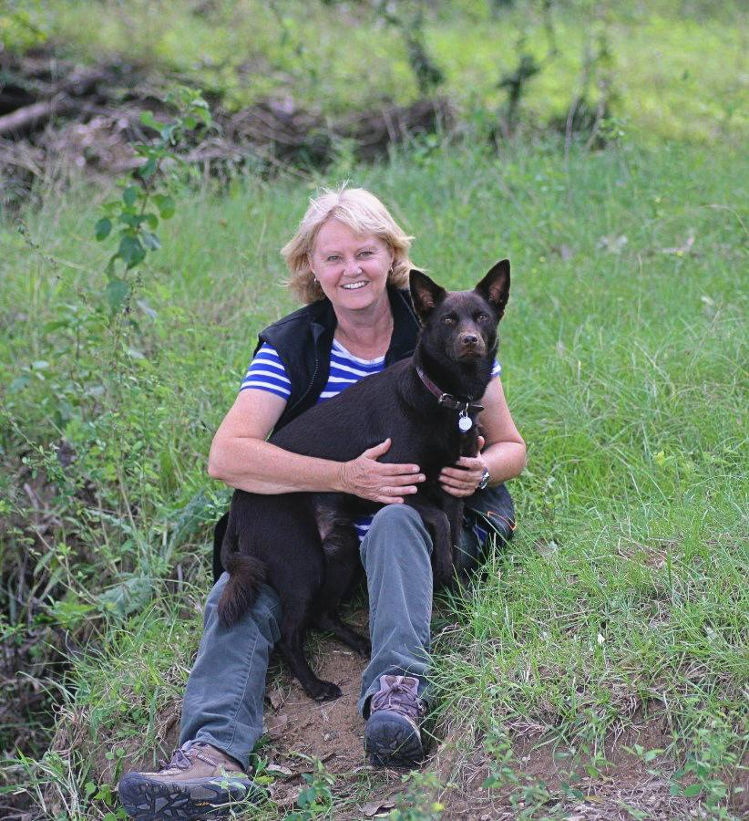

Dogs ACT
Track and Search Workshop

There are working and auditing spots available at the workshop. Working spots will be allocated to ensure we have a good cross-section of dogs and handlers from experienced to less experienced to promote a constructive practical learning experience for all attendees.

There are 8 working spots available. Numbers for auditing spots are not fixed but will take account of available space and participant comfort.

Please complete the relevant forms below and send to Julie Cutts at Jarrah236@gmail.com.
If you have any questions, please either email me, or contact me on 0438 931 712.

Working spots will be allocated by the end of January 2020 and you will be notified as to whether you have a working spot or not. Preference will be given to ACT trackers in the first instance.

Dogs ACT will raise an invoice and send it to you so that you can pay for your spot. Payment should be made by 29 February 2020. Any working spots not paid by this date will be reallocated.

Application for working spot: $170

Handler’s name: ……………………..……………………………………………………………………………………………..
Contact details:
Email: …………………………..………………………………………………………………………………………..
Phone: ……………………..……………………………………………………………………………………………..
Dogs ACT member ………………………………………………………….…………………………………………………………
Other affiliate (name) …………………………………………………….…………………………………………………..
Dog’s name: …………………….……………………………………………………………………………………………..
Dog’s breed: …………………….……………………………………………………………………………………………..
Dog’s age: …………………….……………………………………………………………………………………………..
Dog’s tracking experience and level obtained
………...……………………………………………………………………………………………………………………………………………
If you are not allocated a working spot, will you be interested in an auditing spot? YES/NO

Application for auditing spot: $90

Handler’s name: …………………….……………………………………………………………………………………………..
Contact details:
Email: ……………………..…..………………………………………………………………………………………..
Phone: …………………….……………………………………………………………………………………………..
Dogs ACT member ……………………………..……………………………………………………………………………………
Other affiliate (name) ……………………………………...………………………………………………………………..

