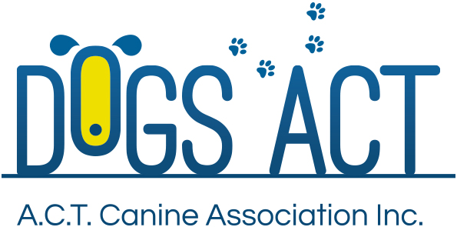
ACT Canine Association Inc. (ABN 11150955611) trading as Dogs A.C.T.

Exhibition Park, Federal Highway, Mitchell, ACT.
PO Box 815, Dickson ACT 2602. Phone 02 62414404.
Email: administrator@dogsact.org.au or visit: http://www.dogsact.org.au
Office hours 9.30am to 2.30pm Tuesday to Thursday

AGILITY & GAMES JUDGES APPLICATION FORM

Surname:
Given Names:
Dogs ACT Membership: |  | Date Joined:
Address:
Phone: |  | Mobile:
Email:

I declare that:
- I have been a member of an Australian Canine Control Body for a minimum of (5) five years.
Give details if other than Dogs ACT.
- I am over twenty-one (21) years of age.
- I am a resident in the A.C.T.
- I have trained and titled a dog to its Agility Dog (AD) title.
Name of Dog:
ANKC Registration No:
Details of Qualifying Scores which you personally achieved.
Trial (Club):
Date: |  |  | Judge:
Trial 2:
Date: |  |  | Judge:
Trial 3
Date: |  |  | Judge:

- I have been an active instructor at a Dogs ACT affiliated training club in the sport of Agility for a minimum of two (2) years (see reverse of application for confirmation by relevant training club.)
Signed: | Date:

NOTES:

- For the purposes of the Dogs ACT Judges Courses, the term `qualified' means that the applicant must have successfully completed a formally structured Instructors Course which includes a course syllabus, lectures and theoretical and practical assessment.
- In order to be accepted on a Judges Course, the applicant must be a person approved by Council.
- An approved first time aspirant may need to pass a pre-qualification theory examination based on the general sections of the Rules for the Conduct of Agility & Games Trials.

STATEMENT FROM APPLICANT’S DOG TRAINING CLUB

I confirm that
Is a qualified Agility instructor and has been satisfactorily instructing Agility over the past two (2) years.
Signed: |  |  |  | Date:
Office position with club:
Name of affiliated club.

