ENTRIES CLOSE: Friday 9th September 2016 (no late entries)

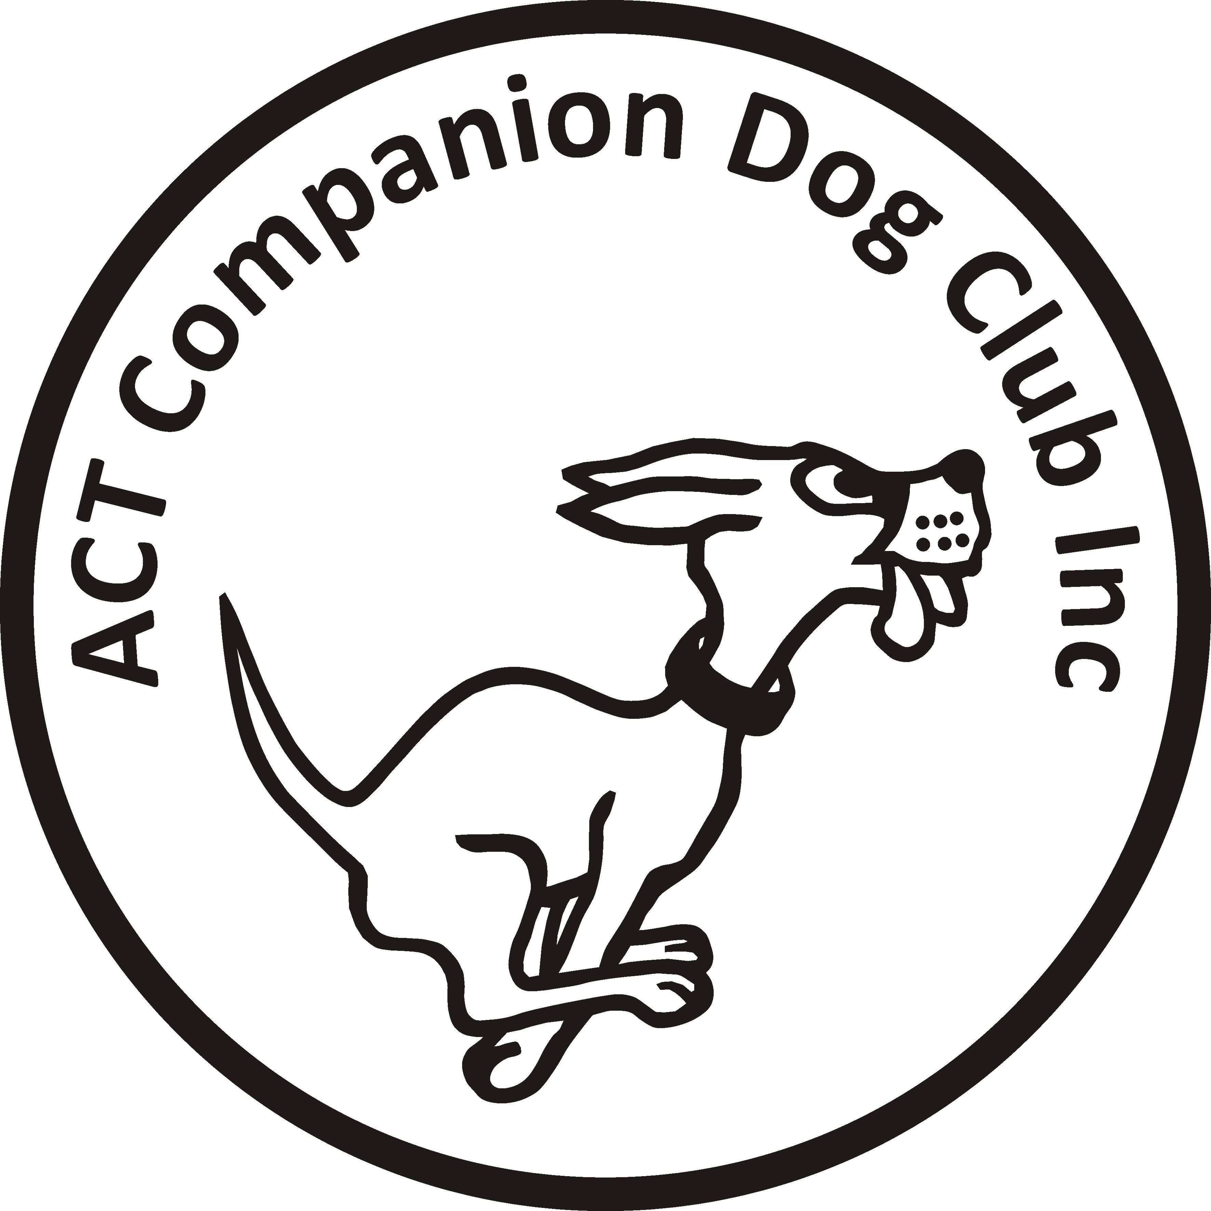
ACT COMPANION DOG CLUB
DOUBLE RALLY OBEDIENCE TRIAL
Saturday 17 September 2016
Venue: ACT CDC grounds, Cnr Jerrabomberra Ave &Narrabundah Lane, Symonston ACT 2609

Judges | Trial 1 | Trial 2
Novice | Ms Tracy Geary (NSW) | Mrs Judy Van Der-Vegt (NSW)
Advanced A & B | Ms Tracy Geary (NSW) | Mrs Judy Van Der-Vegt (NSW)
Excellent A & B | Mrs Judy Van Der-Vegt (NSW) | Ms Tracy Geary (NSW)
Masters | Mrs Judy Van Der-Vegt (NSW) | Ms Tracy Geary (NSW)

Trial 1 commences: 0900  Check-in: 0815-0845  Printed catalogue $2 or free by email  Entry fee: S11 per individual class, or $20 per dog for RAE (combined entry of Adv/Exc B) |  | PM Trial commences: not before 1200  Check-in: 1115-1245  Printed catalogue $2.00 or free by email.  Entry fee: $11 per individual class, or $20 per dog for RAE (combined entry of Adv/Exc B)
Pay CDC entries online –
BSB: 032-729, Account Number: 235628, Reference: RO1709 (for Rally-O) + your surname + phone number; or by cheque/money order. PLEASE DO NOT SEND CASH THROUGH THE MAIL

NOTE: Catalogue for the trial is available FREE via email no earlier than 3 days before the trial. Please provide email address with entries.
NEW - Dogs ACT Regulation: Judges may compete provided they do not do so in classes they have been contracted to judge
The Club reserves the right to amend the judges and judging order should the entries require.

Entries to: Rally Obedience Trial Manager, ACT Companion Dog Club,
PO Box 4048,
Kingston ACT 2604
Phone: 6295 7764 (10-1pm, M-F) or 0411 262 655 (AH)
Email: daingeann@gmail.com (enquiries only. Emailed entries will not be accepted, all entries to be on approved ANKC Obedience entry forms)
Awards: Sash for 1st, 2nd and 3rd place getters (Qualifying scores only). Sash for titles gained on the day.

