ENTRIES CLOSE FOR ALL SHOWS STRICTLY on 18 November – Postal ; 21 November - Online

ACT LADIES KENNEL CLUB & ACT JUNIOR KENNEL CLUB
‘CHRISTMAS EXTRAVAGANZA’

6 ALL BREEDS CHAMPIONSHIP SHOWS – AM & PM
FRIDAY 9, SATURDAY 10 & SUNDAY 11 DECEMBER 2016
Exhibition Park, Federal Highway, Canberra
Classes to be judged: 1, 2, 3, 4, 5,10, 11 & 18 (dogs & bitches).
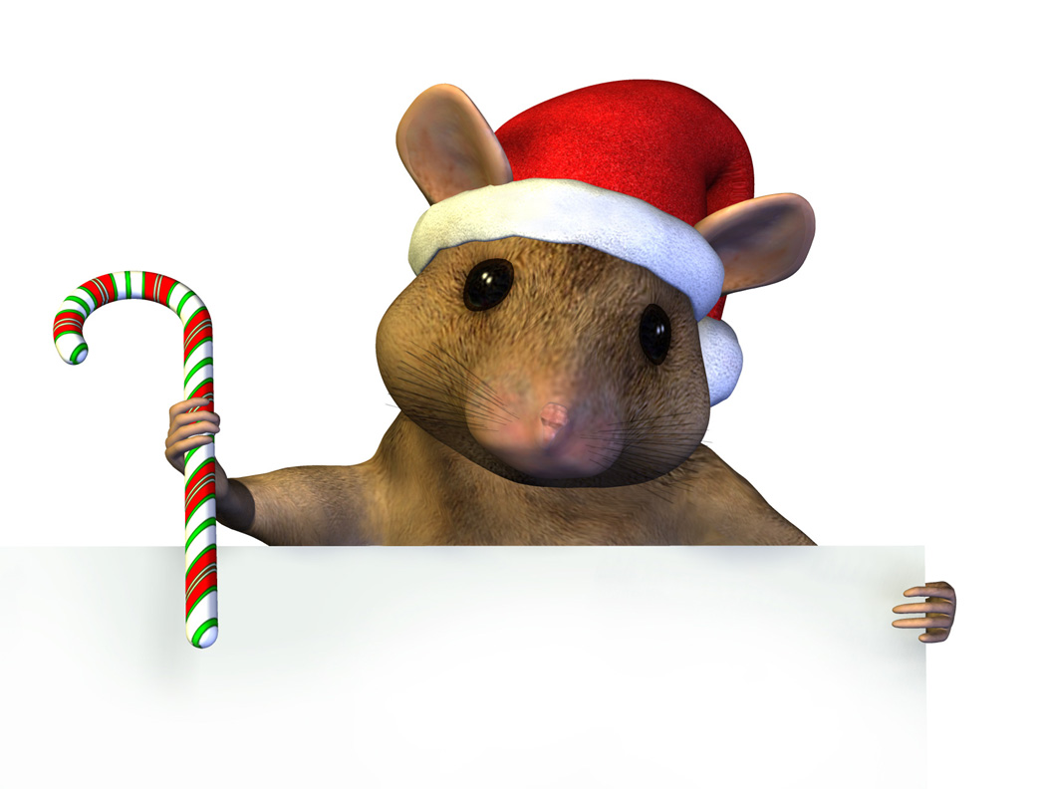
Entries: Mrs Mara Herba - PO Box 51 Captains Flat NSW 2623; siberians@ozemail.com.au ; Ph: 6236 6404
Exhibitors to please ensure each entry clearly indicates correct Club and Show/s
Cheques to be made payable to either: ‘ACT Ladies Kennel Club’ for AM shows; or
‘ACT Junior Kennel Club’ for PM shows

 | ACT  LADIES  Fri AM | ACT JUNIORS  Fri PM | ACT  LADIES  Sat AM | ACT  JUNIORS  Sat PM | ACT  LADIES  Sun AM | ACT  JUNIORS  Sun PM
Toys | H Morrison (TAS) | G Love  (SA) | C Redhead  (SA) | C Donaldson  (QLD) | B Redhead  (SA) | T Collicut  (TAS)
Terriers | B Redhead  (SA) | H Morrison (TAS) | G Love  (SA) | D Bowey  (VIC) | C Redhead  (SA) | C Donaldson  (QLD)
Gundogs | B Ranie  (ACT) | B Redhead  (SA) | D Bowey  (VIC) | C Redhead  (SA) | T Collicut  (TAS) | H Morrison  (TAS)
Hounds | T Collicut (TAS) | B Ranie  (ACT) | C Donaldson  (QLD) | B Redhead  (SA) | G Love  (SA) | D Bowey  (VIC)
Working | C Redhead  (SA) | C Donaldson  (QLD) | H Morrison  (TAS) | T Collicut  (TAS) | D Bowey  (VIC) | G Love  (SA)
Utility | G Love  (SA) | T Collicut  (TAS) | B Redhead  (SA) | H Morrison  (TAS) | C Donaldson  (QLD) | C Redhead  (SA)
Non-Sporting | C Donaldson  (QLD) | C Redhead  (SA) | T Collicut  (TAS) | G Love  (SA) | H Morrison  (TAS) | B Redhead  (SA)
General Specials | C Donaldson | H Morrison | T Collicut | B Redhead | D Bowey | G Love

Order of judging: Morning Shows start at 8.30 am each day with groups in alphabetical order.
Afternoon Shows not before 1pm each day with groups in alphabetical order.

NOTE - On Saturday between AM and PM shows there will be Junior Handlers (including Tiny Tots) followed and a visit from Santa.

Entry Fees: $12.00 per entry ALL classes.
Catalogues: ACT.Ladies KC - $4 (pre-paid with entry) per show
ACT.Junior KC - $4 (pre-paid with entry) per show
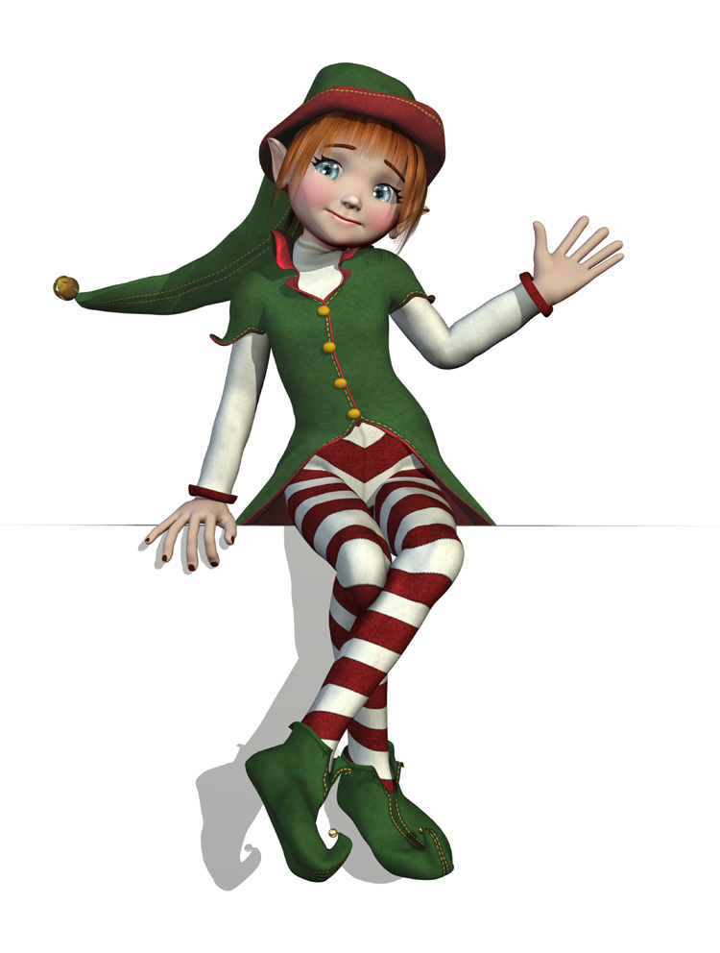
Prizes: Trophy and sash for BIG, RUBIG, BIS, RUBISfor AM shows
Classes in Group and in Classes in Show for all shows.
Cash and sash for PM shows
Prizes for best decorated canopies over the weekend on Saturday!
Excellent prizes for Junior Handlers classes & prizes for all Tiny Tots!
Visit from Santa on Saturday!
Get dressed up in your Christmas gear and join us
for the last ACT shows of the year!


RSVPs for children attending the show are ESSENTIAL to ensure that the elves
have enough goodie bags for Santa to hand out!
Please advise Melanie Buckley via Facebook or phone on 0417 225 292.
Show Committees do not enter or handle exhibits at these events
The Clubs reserve the right to reallocate or change judges
Dogs ACT hot weather policy applies

