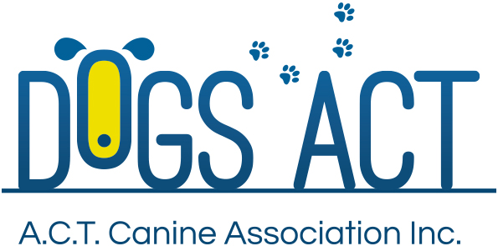
AGILITY - PURE FUN, PURE SPORT, PURE AGILITY

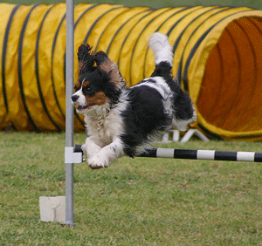
Agility is a fast, exciting, fun activity for you and your dog. Agility involves competitors directing their dogs around obstacle courses in an attempt to both negotiate the obstacles correctly and ‘beat the clock’. The obstacles comprise various types of jumps, ramps, elevated walks, poles that the dogs weave through, different types of tunnels and a see-saw.

Participation in agility training or trialling is great fun. It enables you to provide a release for the energy of your pet and yourself in a way that can be much more interesting and exciting than simply taking your dog for a walk. It helps your family pet to become more responsive to you and also helps you to gain more control and have a more obedient dog. Agility is an exciting way to enhance your leisure time with your dog.
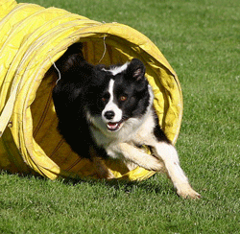
Competitions are held at state and national levels and are structured in a similar manner to equestrian events. The judge designs and sets up the ‘obstacle course’, measures its length and after considering the degree of difficulty calculates a standard time in which the course should be completed by the dog. Each competing dog has to run the course within the set time, negotiate all the obstacles in the correct order and correct manner in order to avoid receiving course or time penalties.

Agility, and its companion activity, jumping are structured for dog owners with all levels of skill and physical ability and provide the opportunity to attain more enjoyment from dog ownership. During actual agility and jumping trials there are several levels of competition ranging from novice level to suit dogs new to the sport to master level for more experienced dogs. There are also jumping competitions at the basic level that include only jumps and tunnels which gives the opportunity for dog owners to join in the fun of trials soon after they begin teaching their dog the sport.
Agility is perhaps the fastest growing dog sport in the world which can be enjoyed by any family owning a dog. Training in agility is available at all of the Obedience Clubs based in the ACT.

If you want to know more about Agility, you should contact any one of the three Obedience Clubs in the ACT:

ACT Companion Dog Club
www.actcdc.org.au ph: 02 6295 7764

Belconnen Dog Obedience Club www.bdoc.asn.au ph: 02 6241 799

Tuggeranong Dog Obedience Club
www.tdc.asn.au ph: 02 6293 4122
Further information
Further information about DOGS ACT activities including getting involved in Rally Obedience, can also be found at www.dogsact.org.au OR call our office and speak to our staff during Business Hours (Tuesday, Wednesday or Thursday – 9.30 to 2.30) on 02 6241 4404.

