ENTRIES CLOSE: Sunday 15th January 2017 (no late entries)

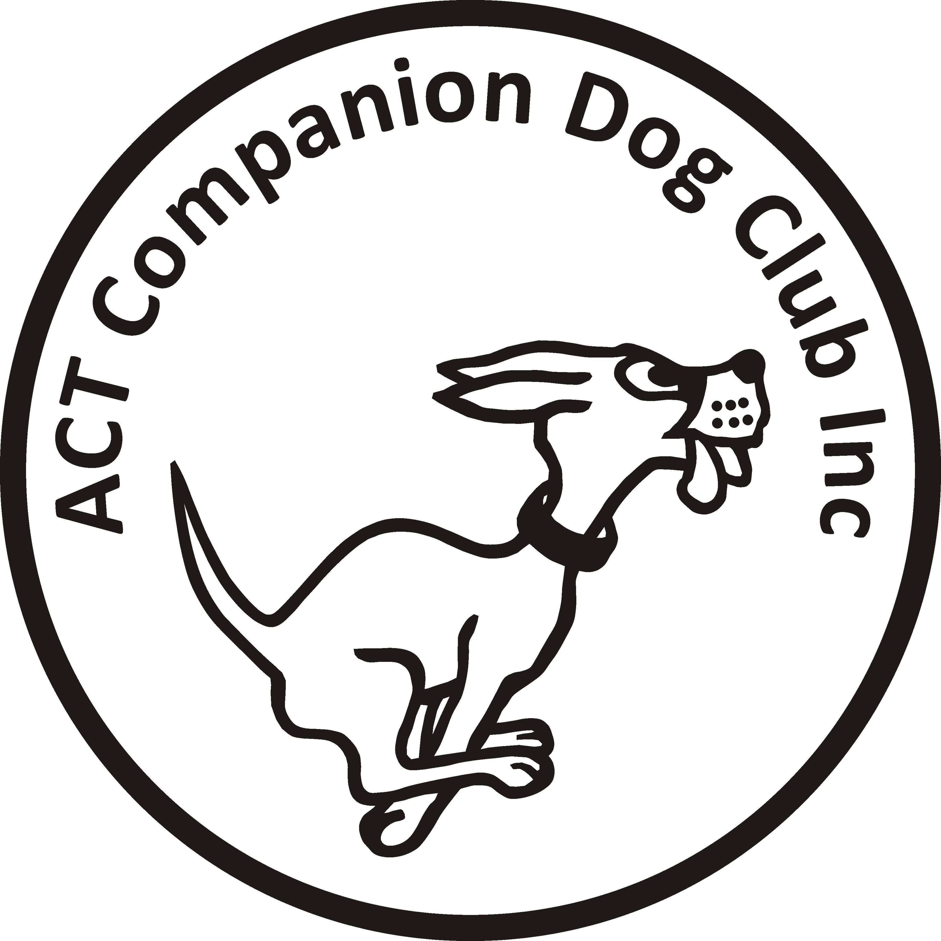
ACT COMPANION DOG CLUB

DOUBLE RALLY OBEDIENCE TRIAL

Saturday 21 January 2017
Venue: ACT CDC grounds, 240 Narrabundah Lane, Symonston ACT 2609

Judges | Trial 1 | Trial 2
Excellent A & B | Ms Elaine Temby (ACT) | Mr John Green (ACT)
Novice | Ms Elaine Temby (ACT | Mr John Green (ACT)
Masters | Mr John Green (ACT) | Ms Elaine Temby (ACT)
Advanced A & B | Mr John Green (ACT) | Ms Elaine Temby (ACT)
Commences | 16:00 | Not before 18:30
Check-in | 15:15 – 15:45 | 17:45 – 18:15

Printed catalogue $2 or free by email. Catalogue for the trial is available FREE via email no earlier than 3 days before the trial. Please provide email address with entries.
Entry fee S11 per individual class, or $20 per dog for RAE (combined entry of Adv/Exc B)
Enter this trial on

Or if you use paper entries, pay your fees online – BSB: 032-729, Account Number: 235628, Reference: RO2101 + your surname + phone number; or pay by cheque/money order. PLEASE DO NOT SEND CASH THROUGH THE MAIL.
Paper Entries to: Rally Obedience Trial Manager, ACT Companion Dog Club, PO Box 4048, Kingston ACT 2604. Phone: 6295 7764 (10-2pm, M-F) or 0411 262 655 (AH)
Email: daingeann@gmail.com (enquiries only. Emailed entries will not be accepted, all entries to be on approved ANKC Obedience entry forms, separate form for each trial)
Dogs ACT Regulation: Judges may compete provided they do not do so in classes they have been contracted to judge.
The Club reserves the right to amend the judges and judging order.
Awards: Sash for 1st, 2nd and 3rd place getters (Qualifying scores only). Sash for titles gained on the day.

