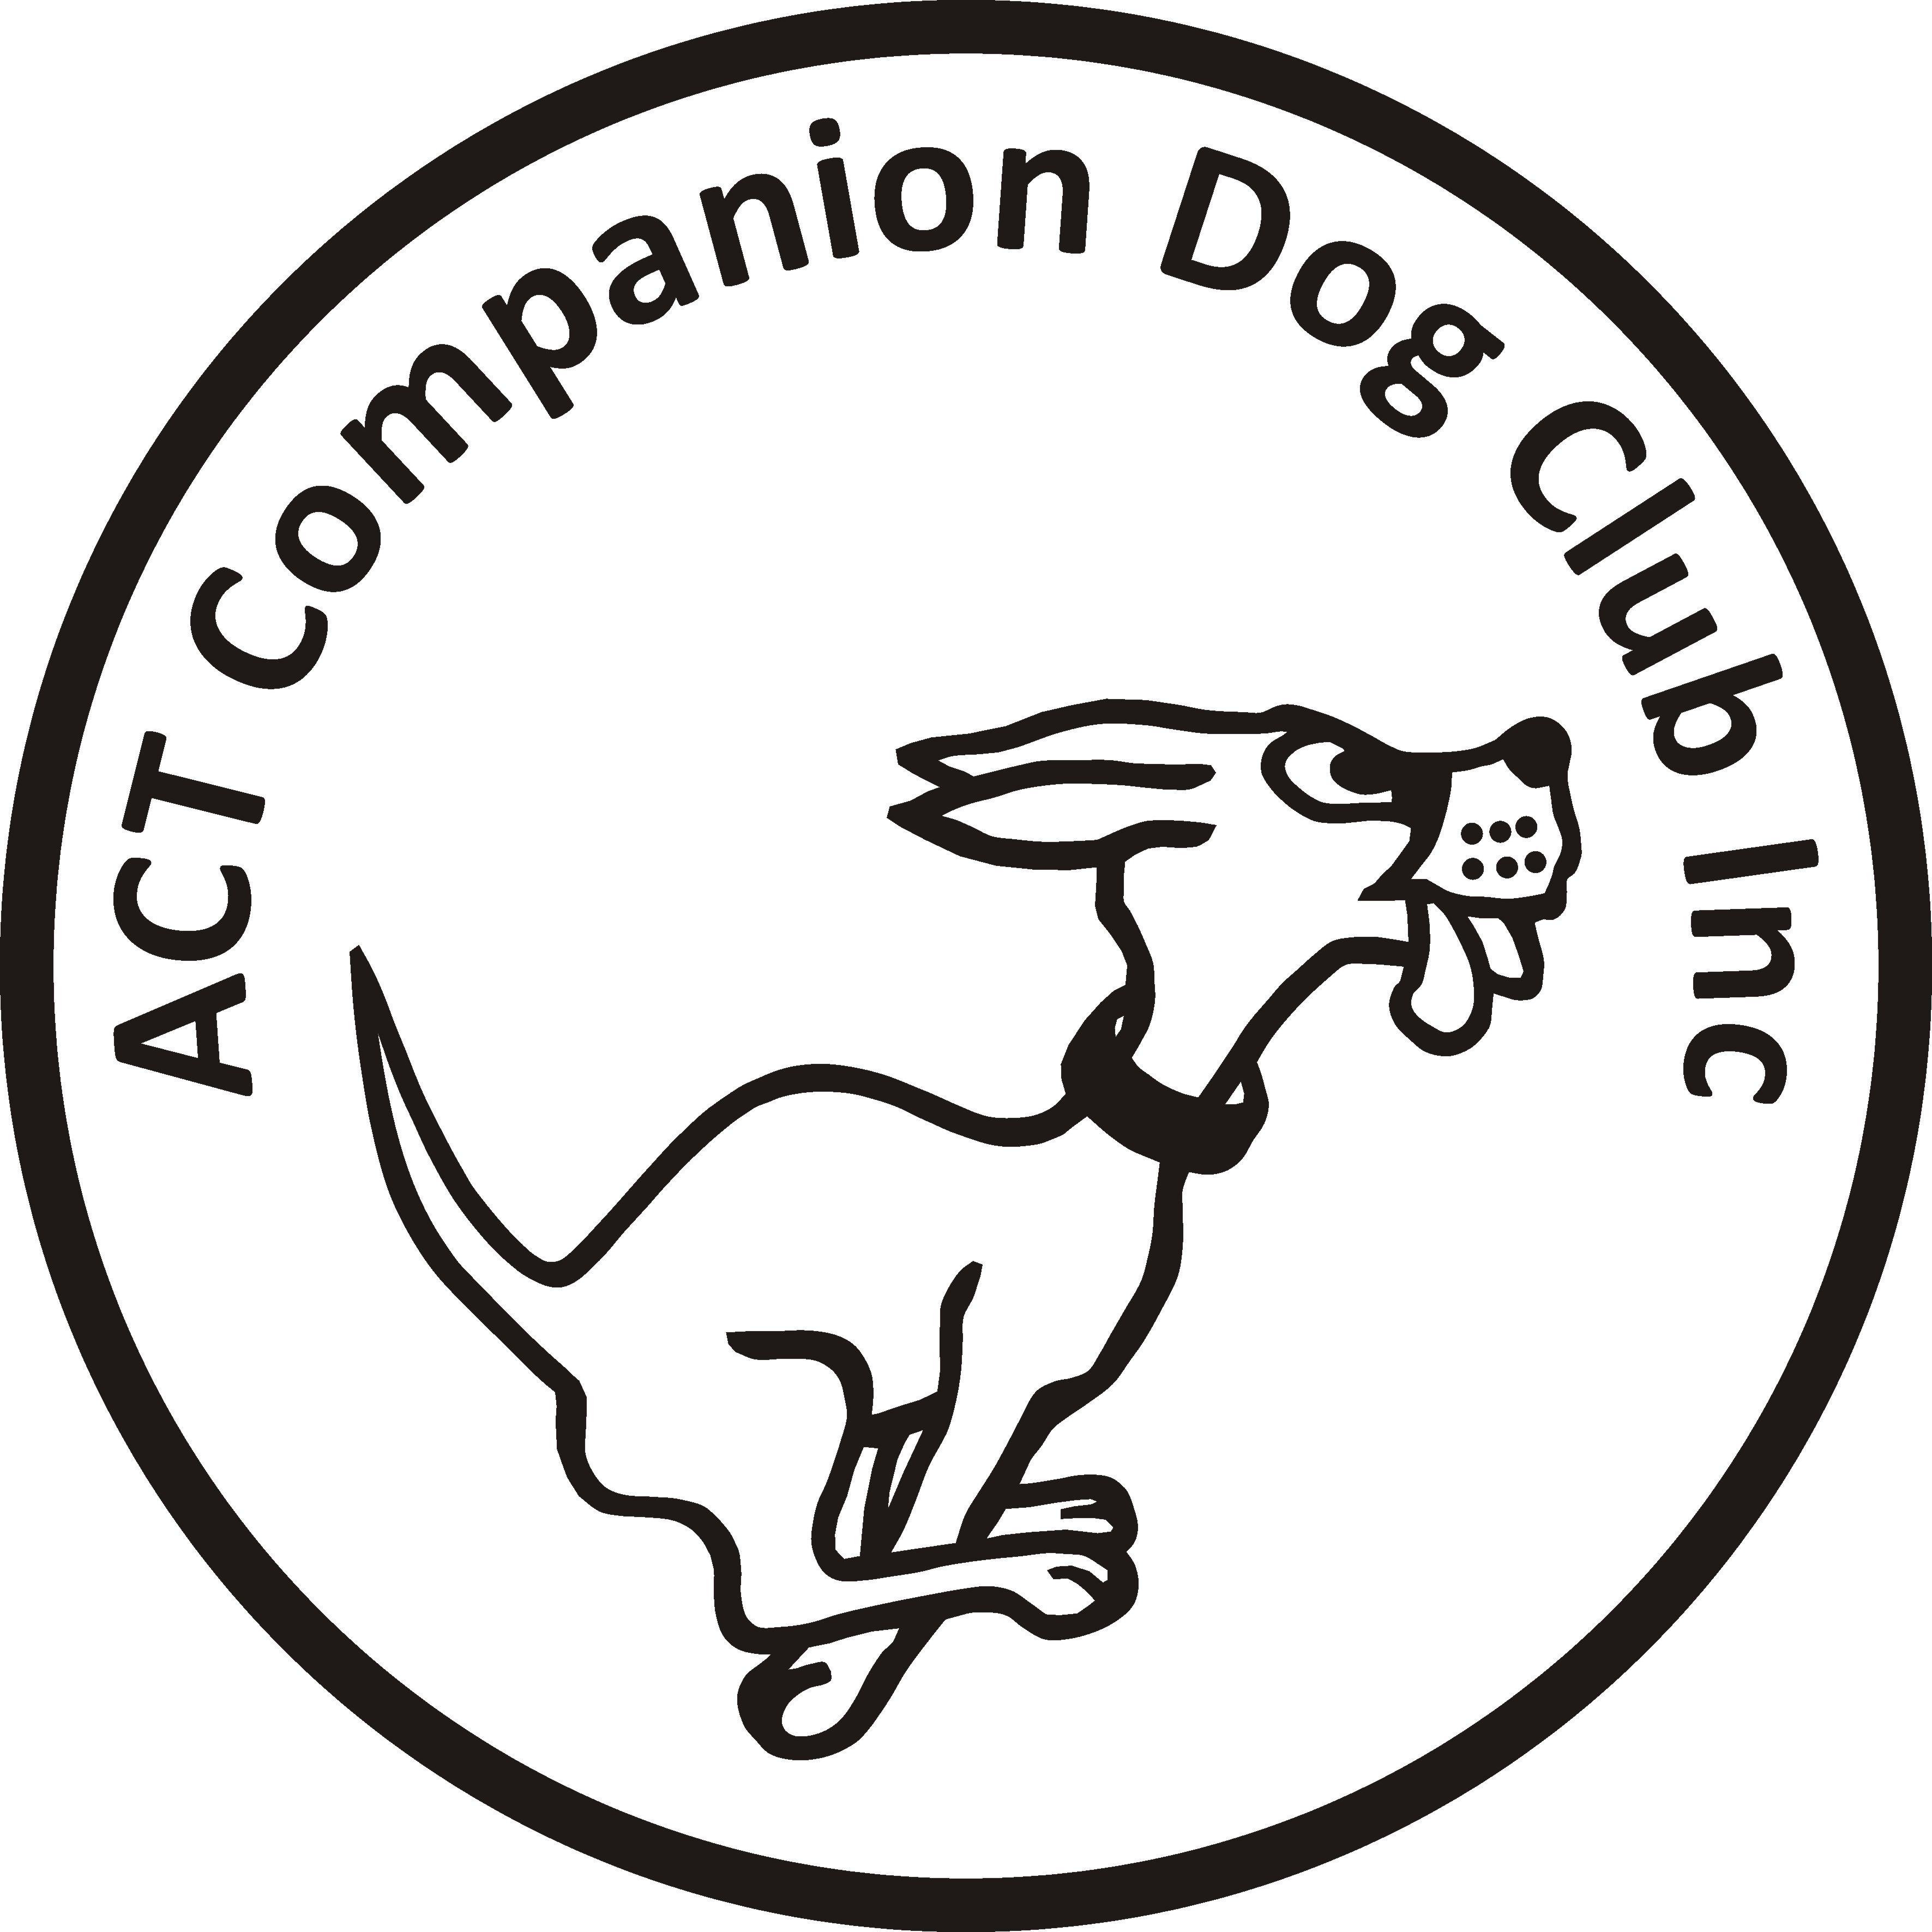
Entries close: Friday 10 March 2017

ACT COMPANION DOG CLUB
EVENING OBEDIENCE TRIAL
6.00pm, Friday 17 March 2017

Venue: ACT CDC grounds, 240 Narrabundah Lane, Symonston ACT 2609

Judges UDX, UD Mr Ritchie Butler (NSW)
CDX Mr John Green (ACT)
CD, CCD Mrs Joanne Hagan (ACT)

Starts 6.00pm
Check-in 5.15-5.45pm
Entry fee $11.00

Entries to Show Manager
Or by post to Obedience Trial Manager, ACT Companion Dog Club, PO Box 4048, Kingston ACT 2604. Pay online: ACT CDC - BSB: 032-729, Account: 235628, Ref: OB0317 + surname + phone number
Catalogues posted on ACT region obedience & rallyo trialling group Facebook page
or, if requested, to email address on your entry form.

All enquiries Judith Barlow - 0403 199 847 no calls after 9pm, judespitz@netspeed.com.au
Awards Sash for 1st, 2nd and 3rd place for qualifying scores.
Sash for all qualifying scores and titles gained on the day.
Notes: The Club reserves the right to make any changes to ensure the smooth running of the trial, including substituting or appointing additional judges, and accepting or rejecting entries.
No off-leash exercising of dogs on grounds except in designated fenced areas.
The Club shop will be open for meals, refreshments and treats for your dog.

