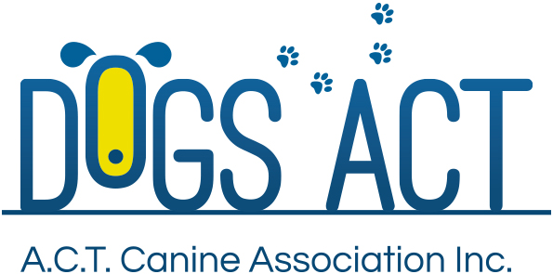

ACT Canine Association Inc. (ABN 11150955611) trading as Dogs A.C.T.

Exhibition Park, Federal Highway, Mitchell, ACT
PO Box 815 Dickson ACT 2602 Phone 02 6241 4404
Email: administrator@dogsact.org.au or visit: http://www.dogsact.org.au

2017 Trainee / Aspirant Lecture Program
All lectures are held at Dogs ACT rooms and commence at 7.30pm

Aspiring Judges’ Lectures (compulsory)

Wednesday 5 April Scheme composition and rules and regulations
Wednesday 3 May Anatomy and glossary of terms
Wednesday 31 May Aspects of judging and critiquing

Practical sessions for aspirants to be conducted at Dogs ACT shows – dates to be advised.

Trainee Judges’ Lectures

Group 1 (Toys)
Thursday 23 March Affenpinscher – Griffon Bruxellois
Thursday 20 April Cavalier King Charles Spaniel – King Charles Spaniel
Thursday 4 May English Toy Terrier – Yorkshire Terrier
Monday 15 May Japanese Chin – Papillon
Monday 29 May Pekingese – Tibetan Spaniel
Thursday 15 June Pomeranian

Group 3 (Gundogs)
Wednesday 29 March Bracco Italiano – Italian Spinone – Pointer
Wednesday 26 April German Shorthaired Pointer – German Wirehaired Pointer
Tuesday 23 May Weimaraner – Weimaraner (Longhair)
Wednesday 7 June Hungarian Vizsla – Hungarian Wirehaired Vizsla
Tuesday 13 June Brittany – Lagotto Romagnolo – Large Munsterlander
Wednesday 5 July Chesapeake Bay Retriever – Curly Coated Retriever – Nova Scotia Duck Tolling Retriever
Tuesday 18 July Flat Coated Retriever – Golden Retriever – Labrador Retriever
Wednesday 9 August Clumber Spaniel – Sussex Spaniel

Group 4 (Hounds)
Monday 27 March Basenji – Beagle
Thursday 27 April Bloodhound – Bluetick Coonhound – B & T Coonhound – Otterhound
Monday 8 May Deerhound – Irish Wolfhound
Wednesday 24 May Foxhound – Hamiltonstovare - Harrier
Tuesday 6 June All varieties of Dachshund
Monday 19 June Finnish Spitz – Norwegian Elkhound
Thursday 6 July All varieties of Peruvian Hairless Dog
Wednesday 19 July All varieties of Portuguese Podengo
Monday 31 July Rhodesian Ridgeback

Group 6 (Utility)
Tuesday 28 March Pyrenean Mastiff – Neapolitan Mastiff – Tibetan Mastiff
Tuesday 4 April Alaskan Malamute – Siberian Husky
Tuesday 2 May Bullmastiff – Mastiff – Cane Corso
Tuesday 16 May Boxer – Rottweiler
Tuesday 30 May Canadian Eskimo Dog - Samoyed
Tuesday 4 July Akita – Akita (Japanese) – Shiba Inu

Trainee and Aspirant program applications close on Thursday, 9 March 2017.

Theory examinations will be held on Wednesday, 19 October 2017.

Practical examinations will be held on dates to be determined in November or December 2017.

Regulations

Applications from trainee judges for theory examinations will only be accepted if the following criteria have been met:
With the exception of Distance Trainee Judges, trainee Judges must attend a lecture on every breed in the group at least once within the previous two (2) years or a submit a one thousand word essay (within fourteen days of the lecture date) on the breed/s missed before applying for a theory examination.

Applications from trainee judges for practical examinations will only be accepted if the following criteria have been met and lodged with the application:
(a) A pass is achieved in the theory examination.
(b) 6.1.2 Module 2 – Practical Experience ANKC regulations:
Judge a minimum of fifty (50) dogs and additionally examine and critique a minimum fifty (50) dogs from the relevant group. The breeds covered must be from, as wide a range as possible, but will include at least five (5) major breeds as determined by the Member Body. This may be achieved by attending field days or shows. All critiques must be countersigned on the day by a licensed judge for that breed who has themselves examined the dogs critiqued. Judging may be in the form of hands on experience by placing dogs at open shows, sweepstakes or field days, but not at breed lectures. (Amended 10/13 – 5.6.4) (Amended 10/14, 7.4.2). All critiques and signed evidence of dogs judged must be submitted at time of applying for Practical Examination.

To apply for a practical examination, the trainee must also comply with 6.1.3 Module 3 – Breed Specialty Show requirement. Trainee judges are to attend a minimum of one (1) breed specialty show for the group or other numbers as set by the Member Body. A written critique on five (5) dogs examined at each event is to be submitted to the Member Body within fourteen (14) days of the event. The critique is to be countersigned by a licensed judge for that group present on the day.

Should a trainee not achieve a pass result in a practical examination, then to qualify to take a further group practical examination a trainee judge must judge a further twenty five (25) dogs and examine and critique a further fifty (50) dogs, in accordance with 6.1.2 of ANKC Regulations and submit the approved enrolment form accompanied by the requirements of this clause. They may then attempt the next available practical examination.

Please refer to the ANKC Regulations Part 3 – Judges Training and Examination Program for all aspirant and trainee requirements: http://ankc.org.au/media/6567/3-ankc-ltd-reg3_judges-train_oct-15.pdf

