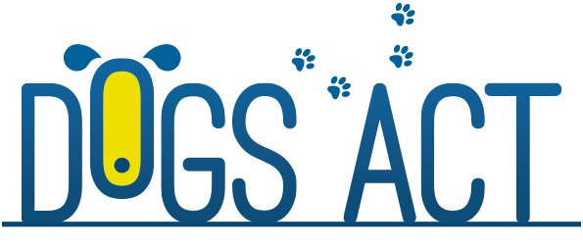

Agility, Jumping and Games Trial
Agility State Titles
23rd & 24th September 2017

Entries close : 8th September 2016
Venue: ACT CDC Club Grounds, Narrabundah Lane, Symonston
Judges:
Saturday 23rd September
Mrs Tenielle Thwaites (NSW) AD, ADX, ADM, ADO, SDM, SDX, SD
Mr Jody Brown (QLD) JDO, JDM, JDX, JD, SPD, SPDX, SPDM
Sunday 24th September STATE TITLES
Mrs Tenielle Thwaites (NSW) ACT Jumping Dog of the Year Final
JDO, JDM, JDX, JD, GDX
Mr Jody Brown (QLD) ACT Agility Dog of the Year Final
AD, ADX, ADM, ADO, GDM, GD

Commences: 9.00am Saturday 23rd 8:30am Sunday 24th
Entry Fees: $10.00 per entry
Entry to Agility & Jumping Dog Of The Year are by invitation and at no charge.
Rules can be viewed on Dogs ACT website & ACT Agility Facebook page.
Catalogues: $10.00 (covers both days) or free digitally via ACT Agility Facebook page or ACT_Agility Yahoo group no sooner than 3 days before the trial
Entries via E Performance (preferred) or with Agility Trial Manager, 18 Euroka Street,
Narrabundah, ACT 2604
Contact: Ph: 0405 345 237 no calls after 9.00pm. Email gundogz@tpg.com.au
Prizes Cash & ribbon for 1st place, prize & ribbon for 2nd & 3rd place.
Prize & Sash for winners of Agility Dog Of The Year and Jumping Dog Of The Year
Not For Competition entries will be accepted in accordance with Dogs ACT Regulations.

