Postal entries close: 16 June 2017 (for both disciplines)
On Line entries close: 23 June 2017 (for both disciplines)

EPIC – ADVANCE DOG SPORTS EXTRAVAGANZA
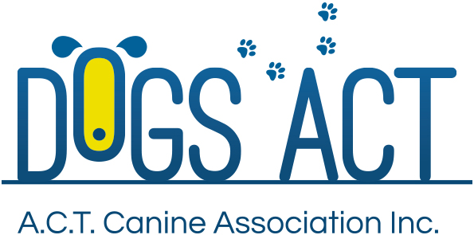
Obedience and Rally O Trials
8 and 9 July 2017
Venue Main Arena, EPIC. Corner of Flemington Road and Northbourne Avenue, Mitchell, ACT
Classes | Judging Commences | Check In | Saturday 8 July | Sunday 9 July
Obedience:  UDX, UD, Open | 10.00am | 9.15 – 9-45am | Mr Ritchie Butler (NSW) | Mr John Green (ACT)
Obedience: Novice, CCD | Not before 11.30am | 10.45 – 11.15am | Mrs Anne Butler (NSW) | Mrs Joanne Hagan (ACT)
Rally Obedience: all classes | 10.00am | 9.15 – 9-45am | Ms Patricia Looker (VIC) | Mr Sid Schuck (NSW)
Entry Fees $12.00 first entry, $10.00 each subsequent entry
Catalogues Electronic catalogue included in entry fee.
Enter online at Easy Dog Entries https://www.easydogentries.com/au/
Or post to Obedience Trial Manager, P.O. Box 815, Dickson, ACT 2602
Enquiries Preferred method of contact: Email elaine.temby@gmail.com. Ph or text: 0414 552 730 – no calls after 8:30pm please
Prizes Prize & ribbon awarded for 1st, 2nd, 3rd places for all classes
Note: For paper entries, please ensure that you provide an entry form for each dog, include the dogs jump height where appropriate and include an e-mail address on each entry form.
Dogs ACT reserves the right to make any changes that will ensure the smooth conduct of the trial, to substitute or appoint additional judges and to accept or reject entries.
Dogs ACT Regulations allow contracted judges to compete in the trials provided they do not do so in the classes they have been contracted to judge

