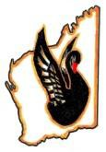
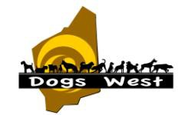

48th National Retrieving Trial Championship for Gundogs

Friday 15th, Saturday 16th and Sunday 17th September 2017
To be held in the Toodyay/Northam/Goomalling area, Western Australia

JUDGES
Mr Ray Johnson (WA)
Ms Eleanor Johnson (WA)

Entries Close: Monday 14th August 2017

Entry Fees: $60 per dog, $50 per dog for second & subsequent entries
- payable to Dogs West

Full Schedule, Payment Form and additional information available at: www.48thnationalretrievingtrialwa.com

Entries & Enquiries to:
Secretary ANRTC Working Party, Ms Judy Pannett, 11 Godwit Glade, Chittering, Western Australia 6084
Email: jpannett@iinet.net.au

Sponsored by Black Hawk, Sporting Outdoor Supplies, Field and Game

*************************
Dogs West State Retrieving Trial
Will be conducted 9th & 10th September 2017.
Please refer to www.48thnationalretrievingtrialwa.com for further information.

