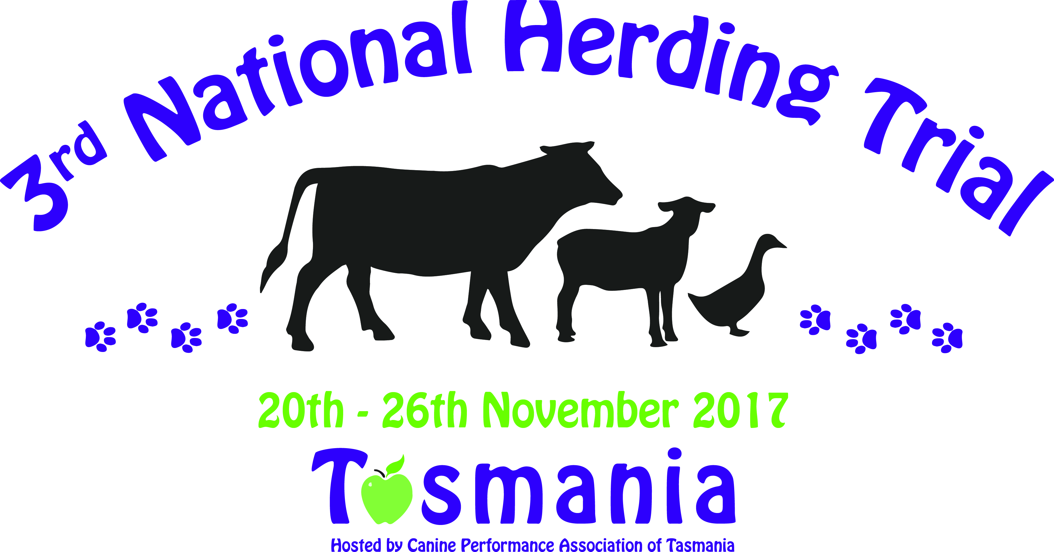
Judge: Mrs Lynn Leach (Canada) Event Manager: Ms Tull Luttrell Ph: 0428123864
Enquiries: herdingnational@gmail.com or join our Facebook Group https://www.facebook.com/groups/1326023180741592/
Schedule available from the secretary; please email Lani Smith mdlmsmith@internode.on.net
Entries close October 10th 2017

