ENTRIES CLOSE: FRIDAY, 25 AUGUST 2017
Two Obedience Trials in Canberra – at the same venue
SATURDAY 2 SEPTEMBER 2017
Venue: ACT CDC grounds, 240 Narrabundah Lane, Symonston ACT 2609
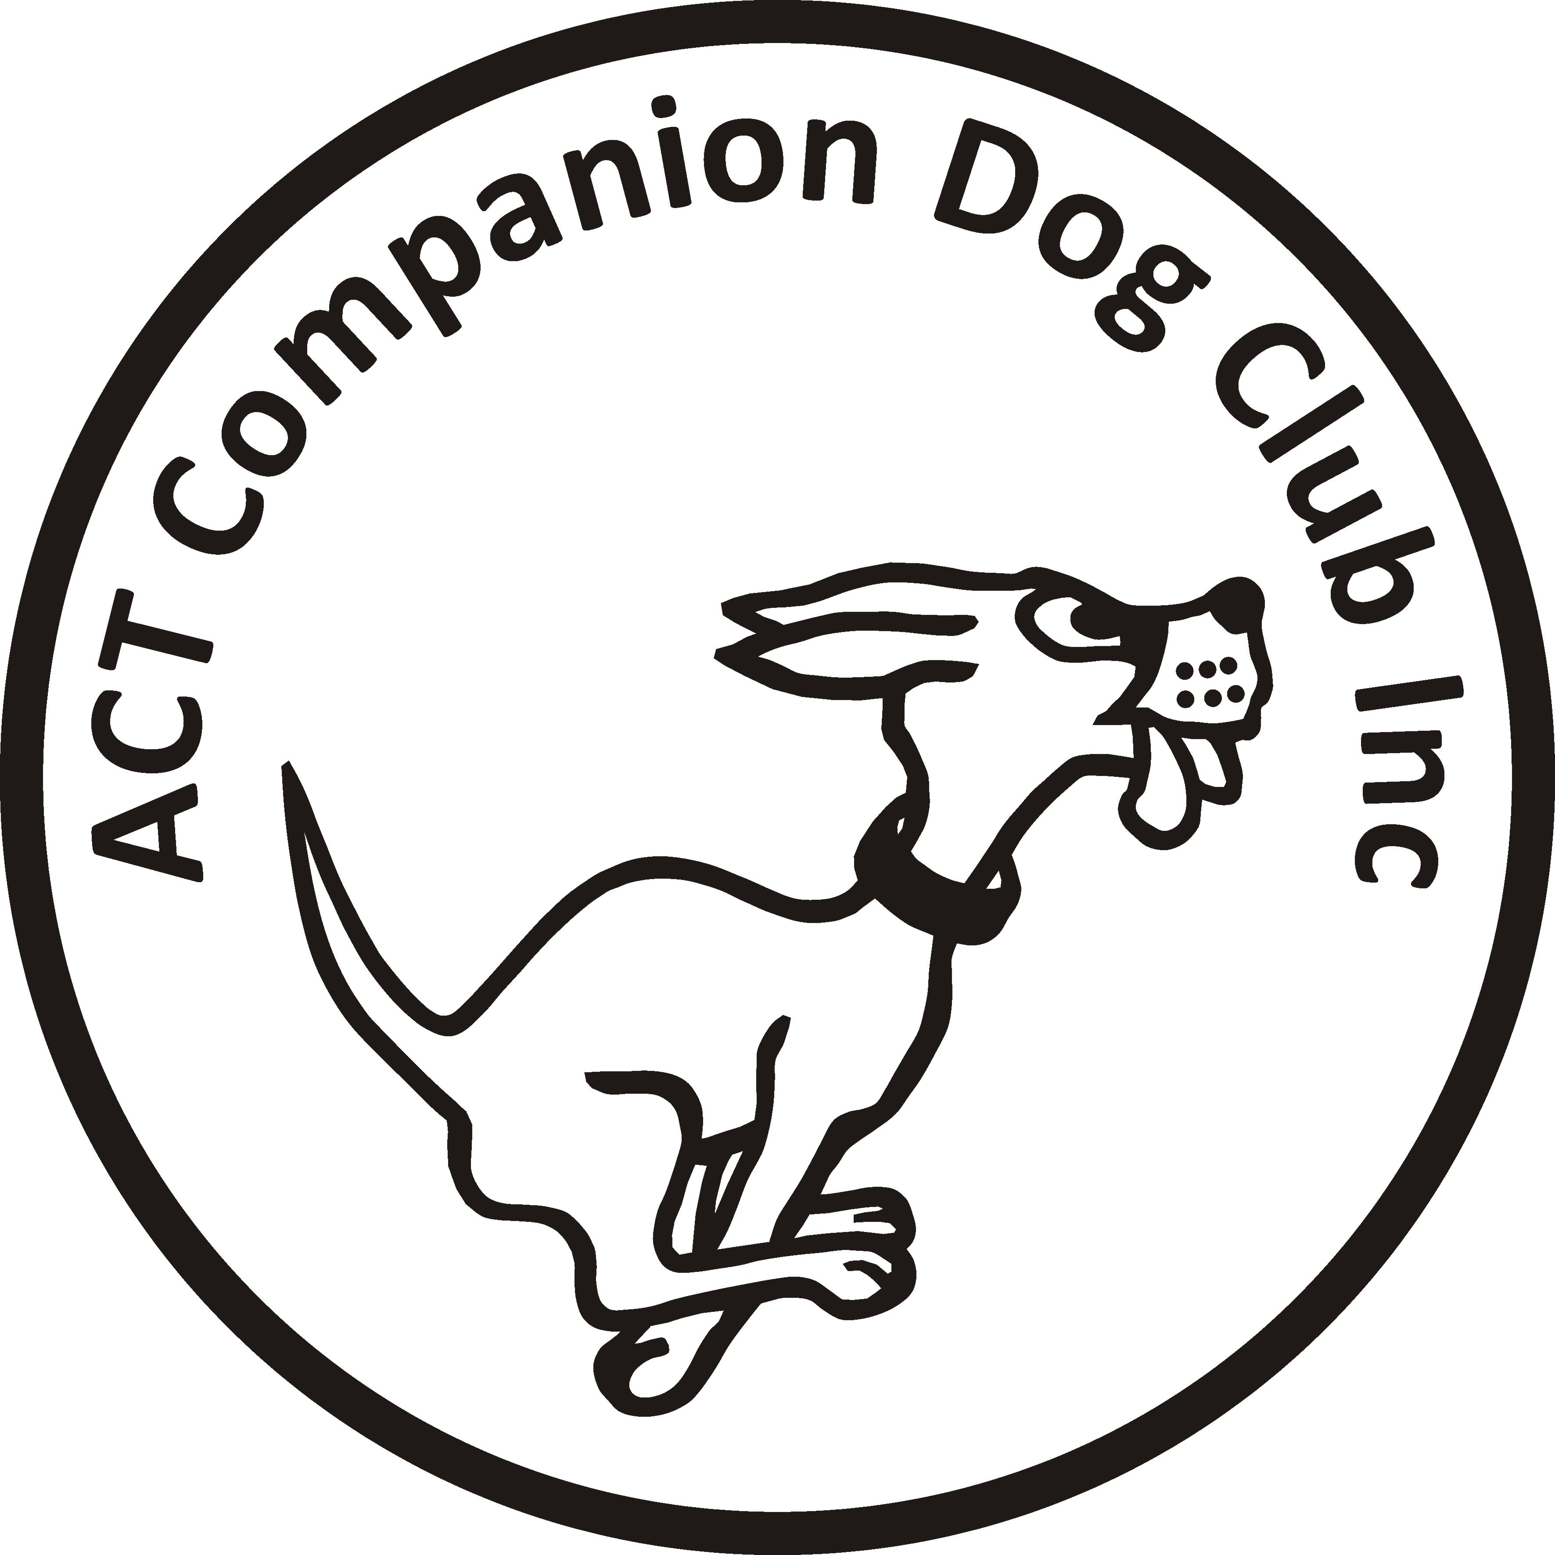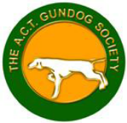

ACT COMPANION DOG CLUB ACT GUNDOG SOCIETY
OBEDIENCE TRIAL OBEDIENCE TRIAL

Judges ACT CDC Trial
Mr Patrick Connoley (NSW) … CDX, CD
Ms Linda Dibbin (NSW) … UDX, UD, CCD

Judges ACT Gundog Trial
Ms Linda Dibbin (NSW)… CDX, CD
Mr Patrick Connoley (NSW) … UD, CCD
Ms Julie Cutts (ACT) … UDX

Judging 9.00am After CDC trial and not before 12.00pm
Check-in 8.15-8.45am Check-in: 11.15-11.45am
Entry fee (each trial) $11.00 $11.00

Entries – Please enter via Show Manager - https://www.showmanager.com.au/ - each trial!
Catalogue (each trial) Posted on the ACT region obedience & rallyo trialling group Facebook page. Free by email, if requested
If posting entries, to | Obedience Trial Manager  ACT Companion Dog Club  PO Box 4048, Kingston ACT 2604 | Obedience Trial Manager  ACT Gundog Society  8 Lovegrove Place, Kambah ACT 2902
If paying online, include these details, and separate payment for each trial | ACT CDC - BSB: 032-729  Account: 235628  Ref: OB0209 + surname | ACT Gundog Society - BSB: 062-905  Account: 135312  Ref: Obed + surname
All enquiries | Judith Barlow – 02 6296 6130, judespitz@netspeed.com.au | Judith Barlow – 02 6296 6130 judespitz@netspeed.com.au
Awards: both clubs Sash for 1st, 2nd and 3rd place (qualifying scores only) and titles gained on the day!
Other awards: each club Sash for all qualifying scores Special sash for Best Gundog in Trial!
Notes: Each Club reserves the right to make any changes to ensure the smooth running of each trial, including substituting or appointing additional judges, and accepting or rejecting entries. No off-leash exercising of dogs on grounds except in designated fenced areas. Refreshments will be available

