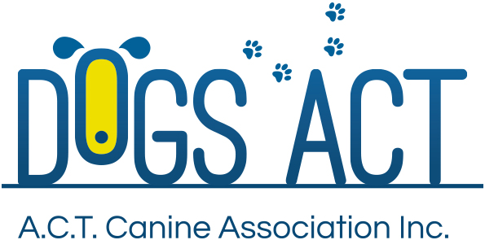

ACT Canine Association Inc. (ABN 11150955611) trading as Dogs A.C.T.

Exhibition Park, Federal Highway, Mitchell, ACT
PO Box 815 Dickson ACT 2602 Phone 02 6241 4404
Email: admin@dogsact.org.au or visit: http://www.dogsact.org.au

APPLICATION FOR THEORY EXAMINATION
for
Trainee Conformation Judges

Applications will only be accepted if the required criteria as per the Rules/Regulations have been met.

I apply to undertake the Trainee / Single Breed Theory Examination to be held on Wednesday, 18 October 2017.

for Group/s . . . . . . . . . . . . . . . . . . . . . . . . . . . . . . . . . . . . . . . . . . . . . . . . . . . . . . . . . . . ..

The fee of $ 70.00 per exam is enclosed.

Membership No:

APPLICANT’S DETAILS:

Name . . . . . . . . . . . . . . . . . . . . . . . . . . . . . . . . . . . . . . . . . . . . . . . . . . . . . . . . . . . . . . . . . . . . . .

Address . . . . . . . . . . . . . . . . . . . . . . . . . . . . . . . . . . . . . . . . . . . . . . . . . . . . . . . . . . . . . . . . . . .

. . . . . . . . . . . . . . . . . . . . . . . . . . . . . . . . . . . . . . . . . . . . . . . . . . . . Post Code . . . . . . . . . . . . . .

Phone – Home . . . . . . . . . . . . . . . . . . . . . . . . . . . . . Work . . . . . . . . . . . . . . . . . . . . . . . . . . . .

Mobile . . . . . . . . . . . . . . . . . . . . . . . . . . . . . . . . . . . . . . . . .

Email . . . . . . . . . . . . . . . . . . . . . . . . . . . . . . . . . . . . . . . . . . . . . . . . . . . . . . . . . . . . . . . . . . . . . .

. . . . . . . . . . . . . . . . . . . . . . . . . . . . . . . . . . . . . . . . . . . . . . . . . . . . . . . . . . . . .
Applicant’s Signature Date

NO LATE APPLICATIONS WILL BE ACCEPTED
FEE $ 70.00 per group
This application, with the fee, must be received in the DOGS ACT OFFICE

by COB, Thursday, 14 September 2017

