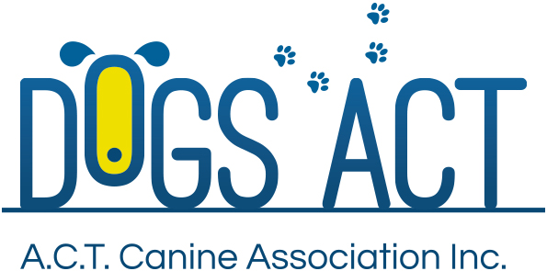
All Breeds & Associates Lure Coursing Trial
Sunday 27 May 2018
Venue: Marchmont Racecourse, Gums Lane, Yass NSW

Entries Close: Paper Tuesday 15 May 2018, Online Friday 18 May 2918.

Judges: Ms Shell Gurney (NSW) & Ms Helen Mosslar (ACT)
Classes: JC, Single, Open, Vets, CA, QC
Judging Order: As per Catalogue

Trial Commences: 10.00am
Check-in: 9.15 to 9.45am
Entry Fee: $18.00
Catalogue Free online or email. $4 on the day
Entries: Dogs ACT Lure Coursing Trial Manager, PO Box 815, Dickson, ACT 2602
Cheques payable to Dogs ACT
Phone & Extreme Weather ph: 0417 669872

Formal Vetting will not be conducted, but club reserves the right to vet any dog or bitch if they deem necessary. Bitches in season may not be trialled.
Club reserves the right to change judging arrangements if necessary.
Sashes 1st, 2nd and 3rd for Sighthounds and Coursing Ability.
Catering and Camping not available on grounds.

