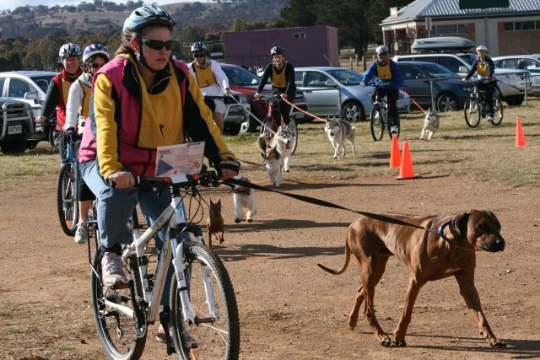
ENDURANCE TEST – Can you and your dog go the distance?

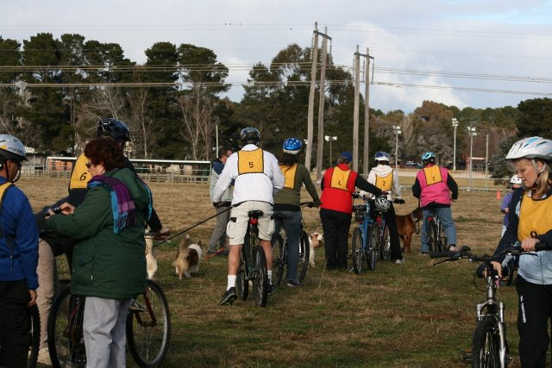

The Endurance Test is an activity where the handler and their dog will complete a course 20km long, over three different surfaces (ie dirt, grass, bitumen, etc), whilst maintaining an average speed of 10km/h

The 20km is run in three legs or sections (8km, 6km & 6km) with a 15-20 min break between them. The dog will undergo four vet checks – one before the test, one after each leg, with the final at the completion of all the running. A “willingness to work” test is completed before the start of the running legs and after the final running leg. A dog must pass all parts to qualify.

The purpose of the Endurance Test, is to demonstrate the dog’s ability to work after being subject to a certain degree of physical strain without showing signs of undue stress or lack of constitution. Dogs need to be fit, sound and free from injury to complete the Test.

Endurance Tests are open to all breeds of dogs, although some dogs will be suited to them and others will not.

This is a cool weather dog sport and the tests are normally conducted in winter.

The test is conducted with up to 20 handler & dogs running in single file behind a pace setter. Most handlers ride a bicycle, but you can also jog with your dog.

Further information
Further information about DOGS ACT activities including getting involved in an Endurance Test, can also be found at www.dogsact.org.au OR call our office and speak to our staff during Business Hours (Tuesday, Wednesday or Thursday – 9.30 to 2.30) on 02 6241 4404.

